Ta Quang Tung – 104222196

COS20019 – Cloud Computing Architecture - Wk8: ACA Module 9 Guided Lab - Creating a Highly Available Environment

**Task 1 - Inspecting your VPC**

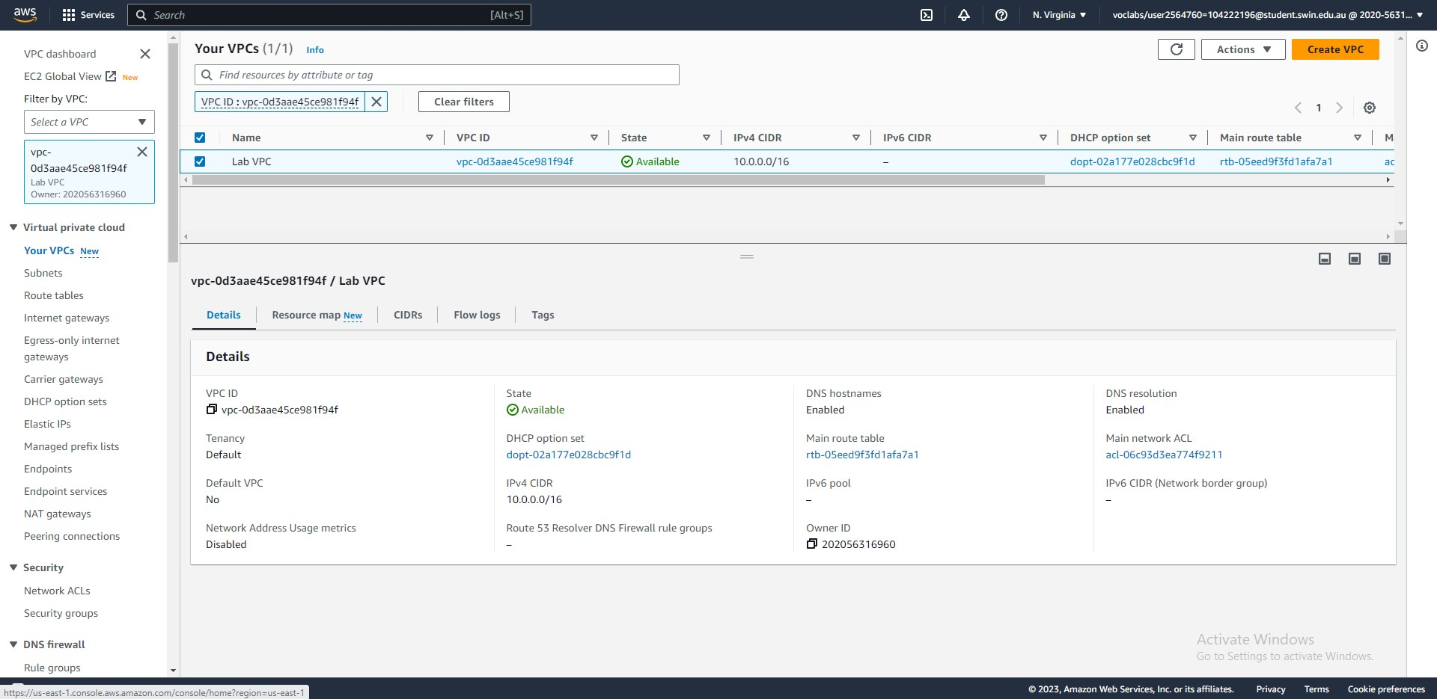



Steps 5-7: The Lab VPC has been set up. Its CIDR range is 10.0.0.0/16.

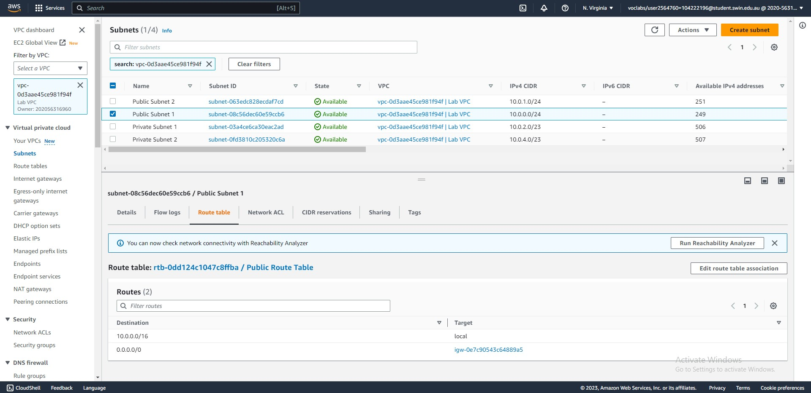



Steps 8-10: The route table of Public subnet 1, which resides in the Lab VPC.

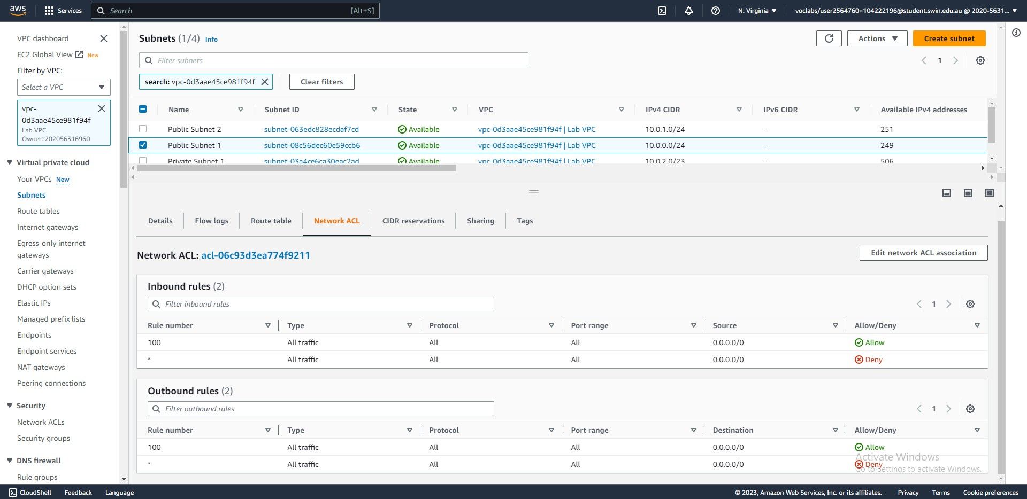



Step 11: The network ACL information of Public subnet 1. At the moment, it allows all inbound and outbound traffic.

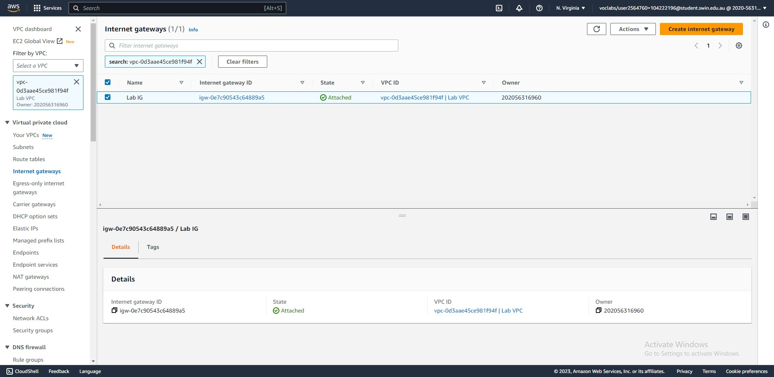



Step 12: An internet gateway named Lab IG has been attached to the Lab VPC.

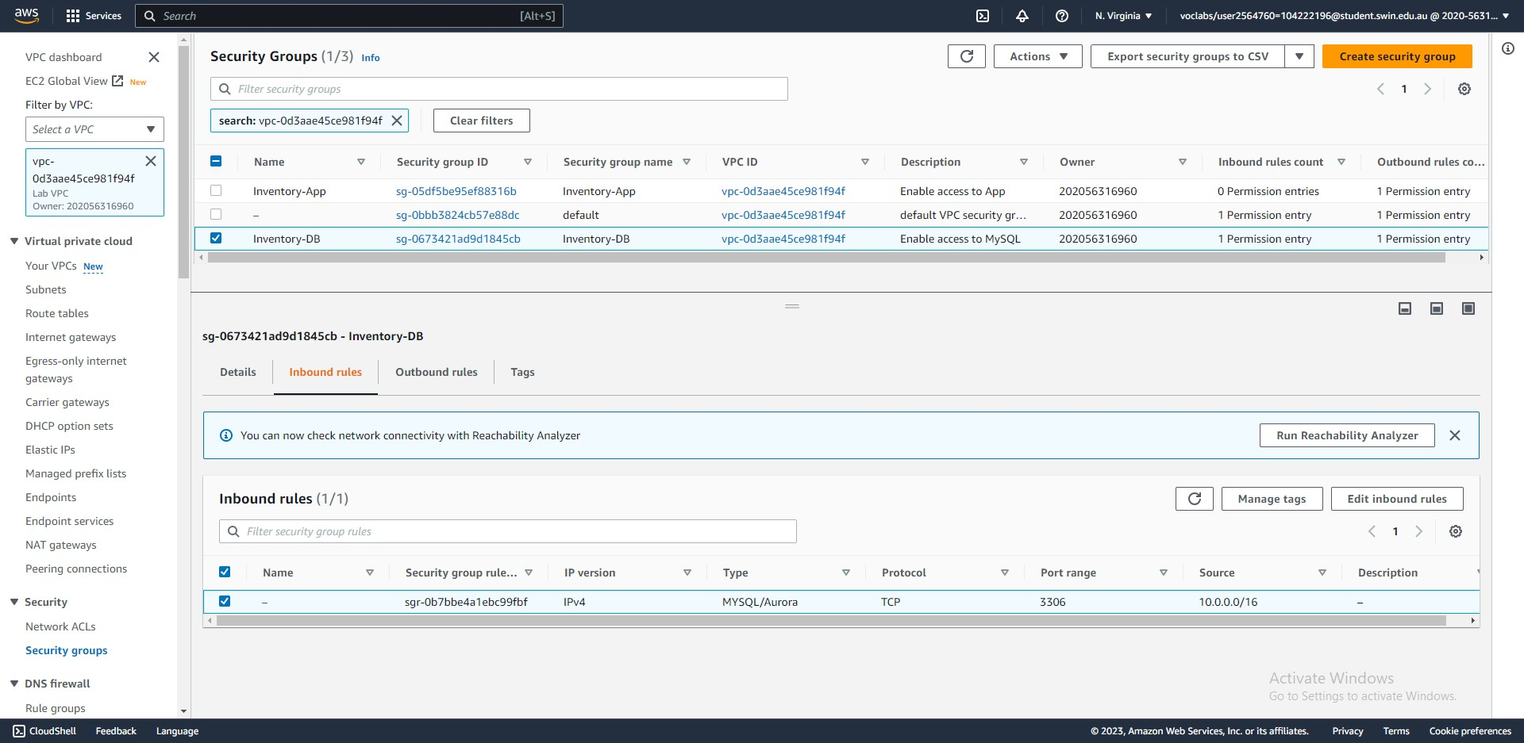



Steps 13-15: The security group Inventory-DB allows inbound MySQL traffic from anywhere in the VPC.

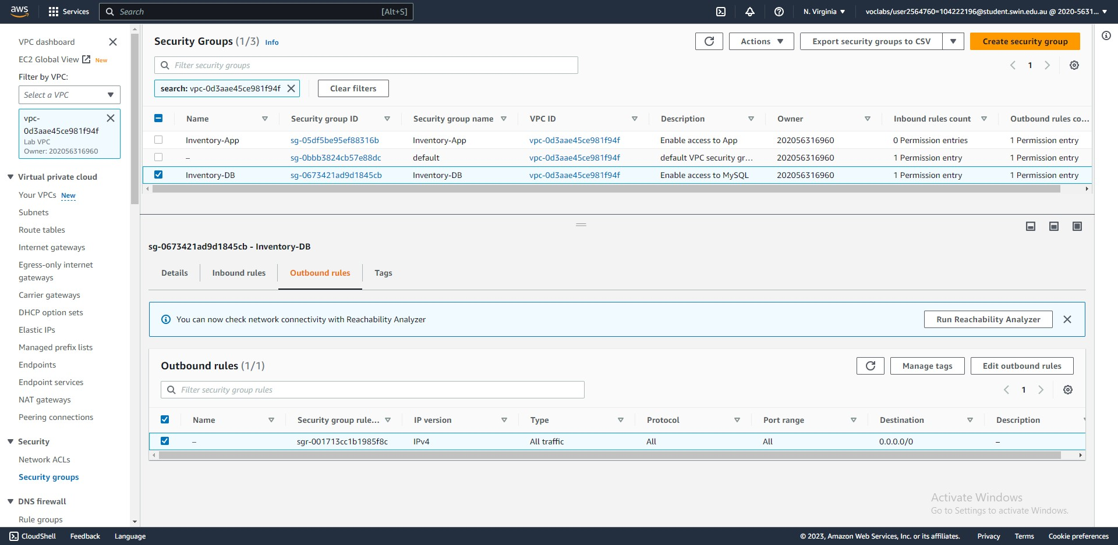



Step 16: The security group allows all outbound traffic.

**Task 2 – Creating an application load balancer**

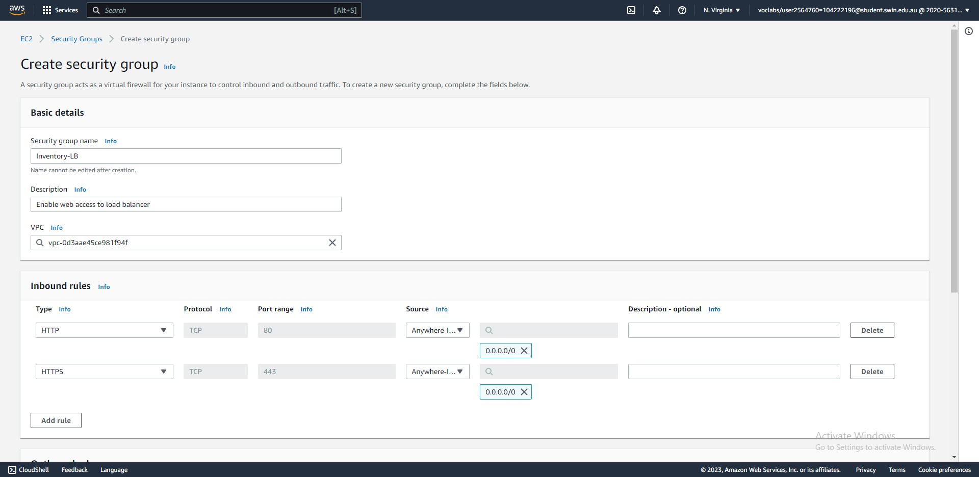



Steps 25-28: Create a new security group that allows all HTTP/HTTPS traffic to the load balancer.

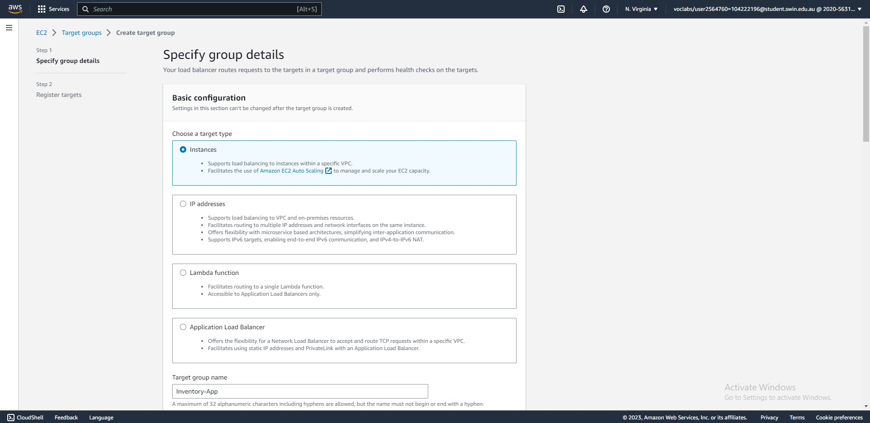



Step 31: Create a target group for the load balancer.

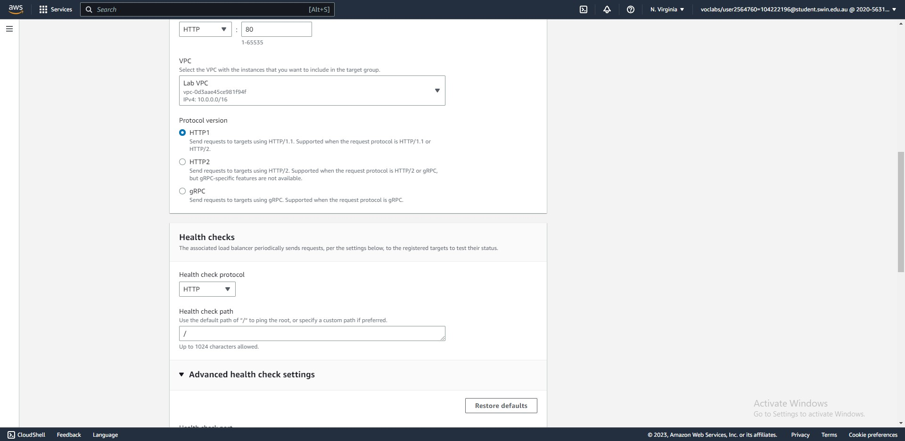



Step 31: Create a target group for the load balancer. (continued)

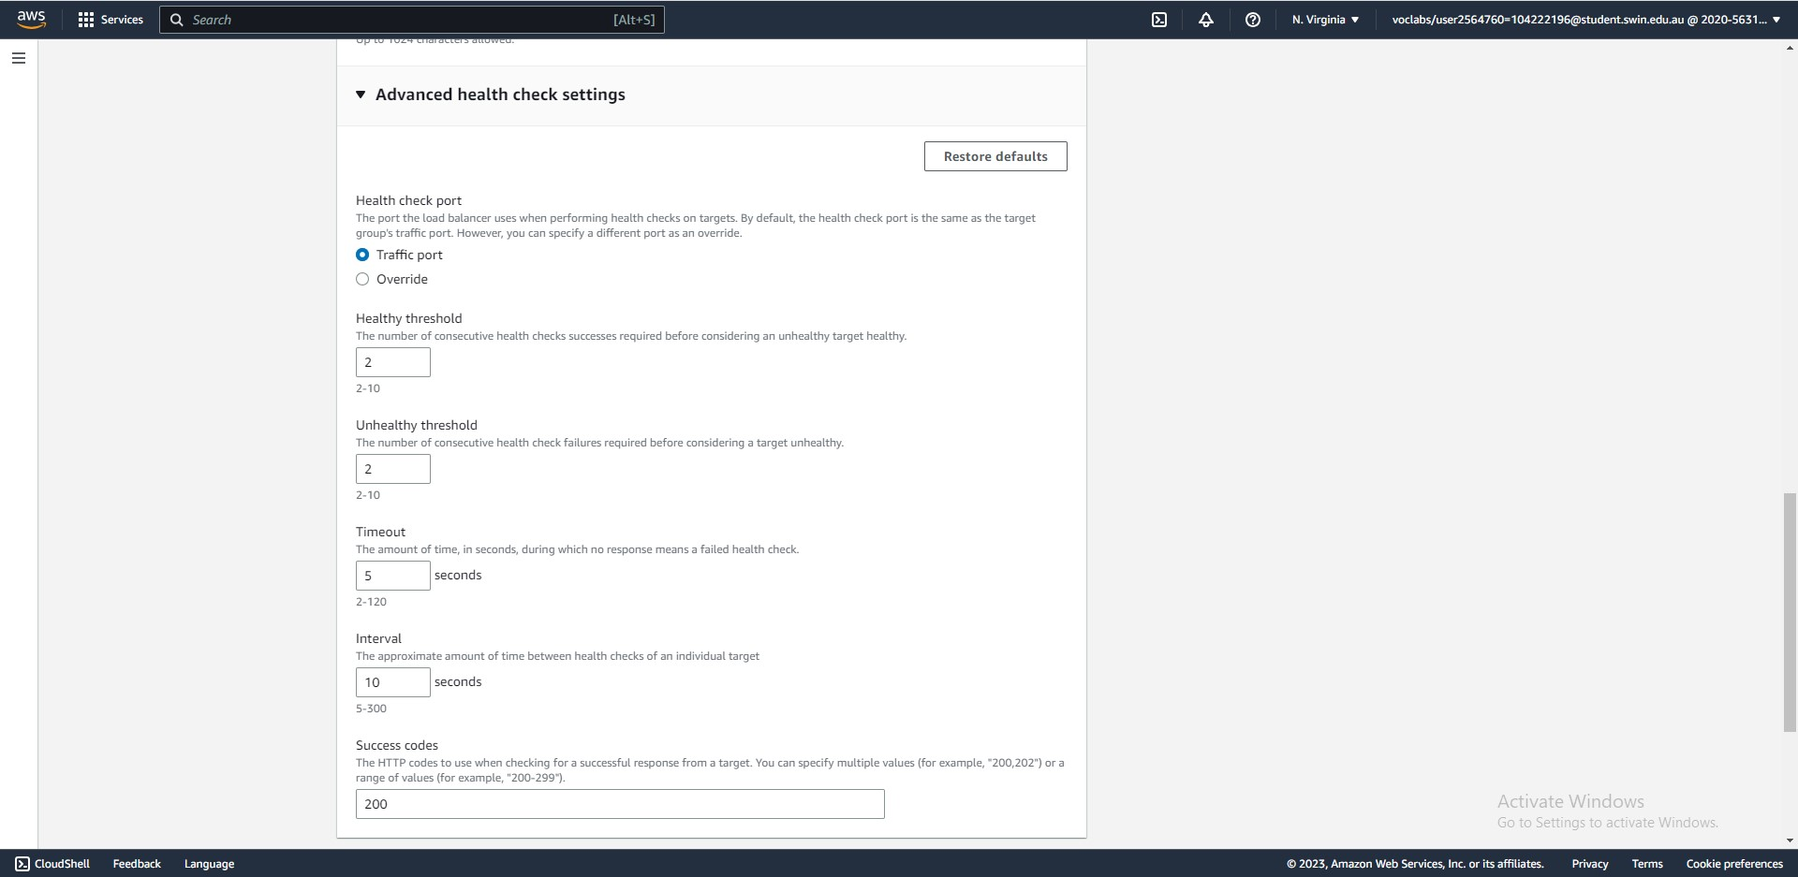



Step 31: Create a target group for the load balancer. (continued)

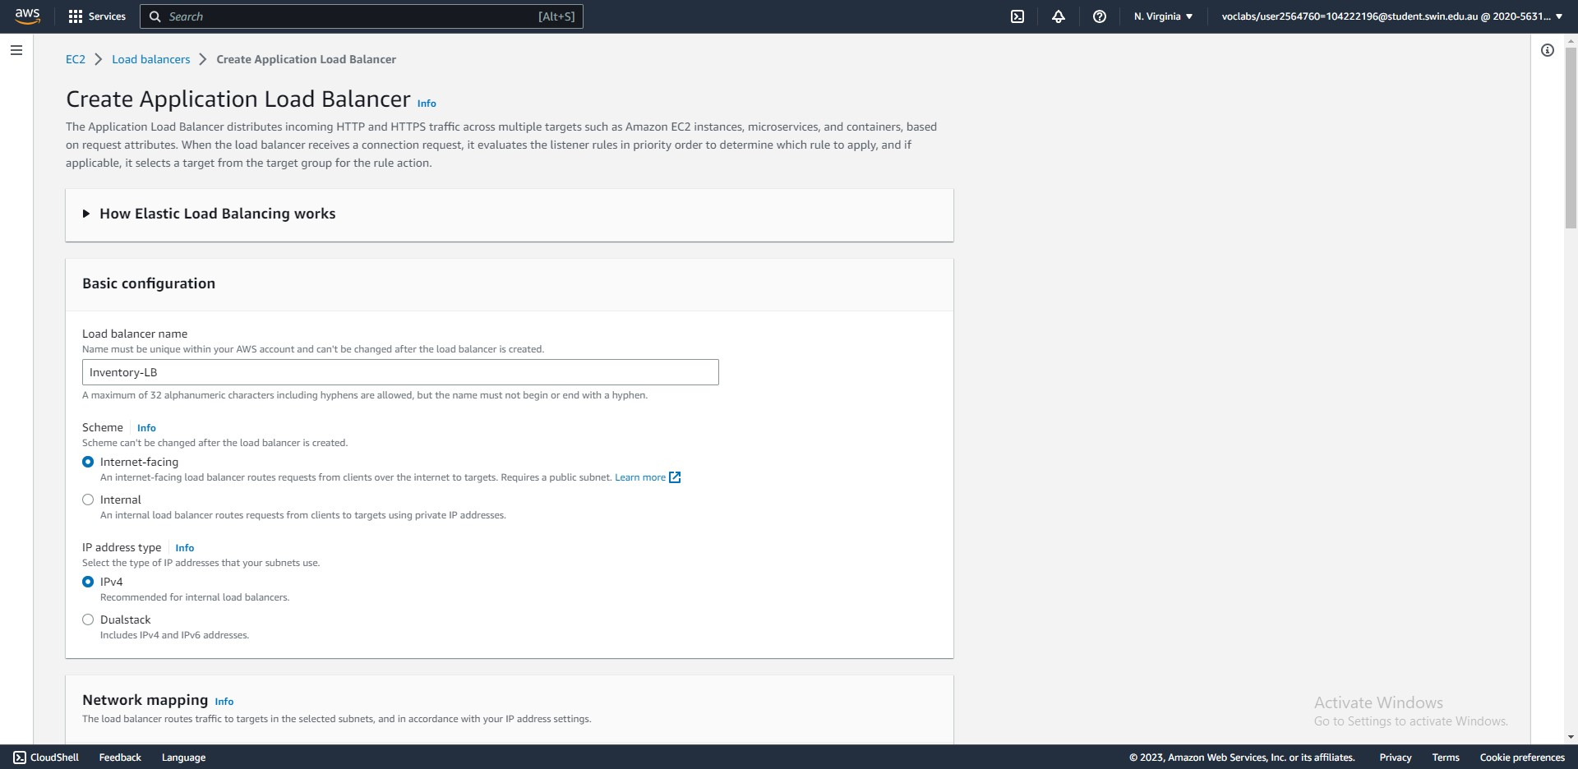



Steps 17-21: Create an application load balancer (set the name to Inventory-LB)

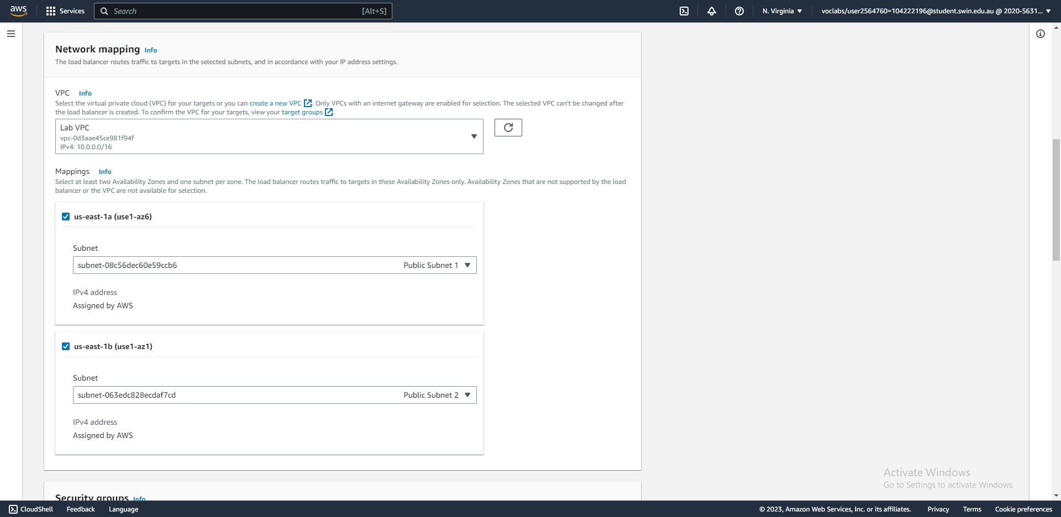



Steps 22-24: Create an application load balancer (select the Lab VPC and the two public subnets)

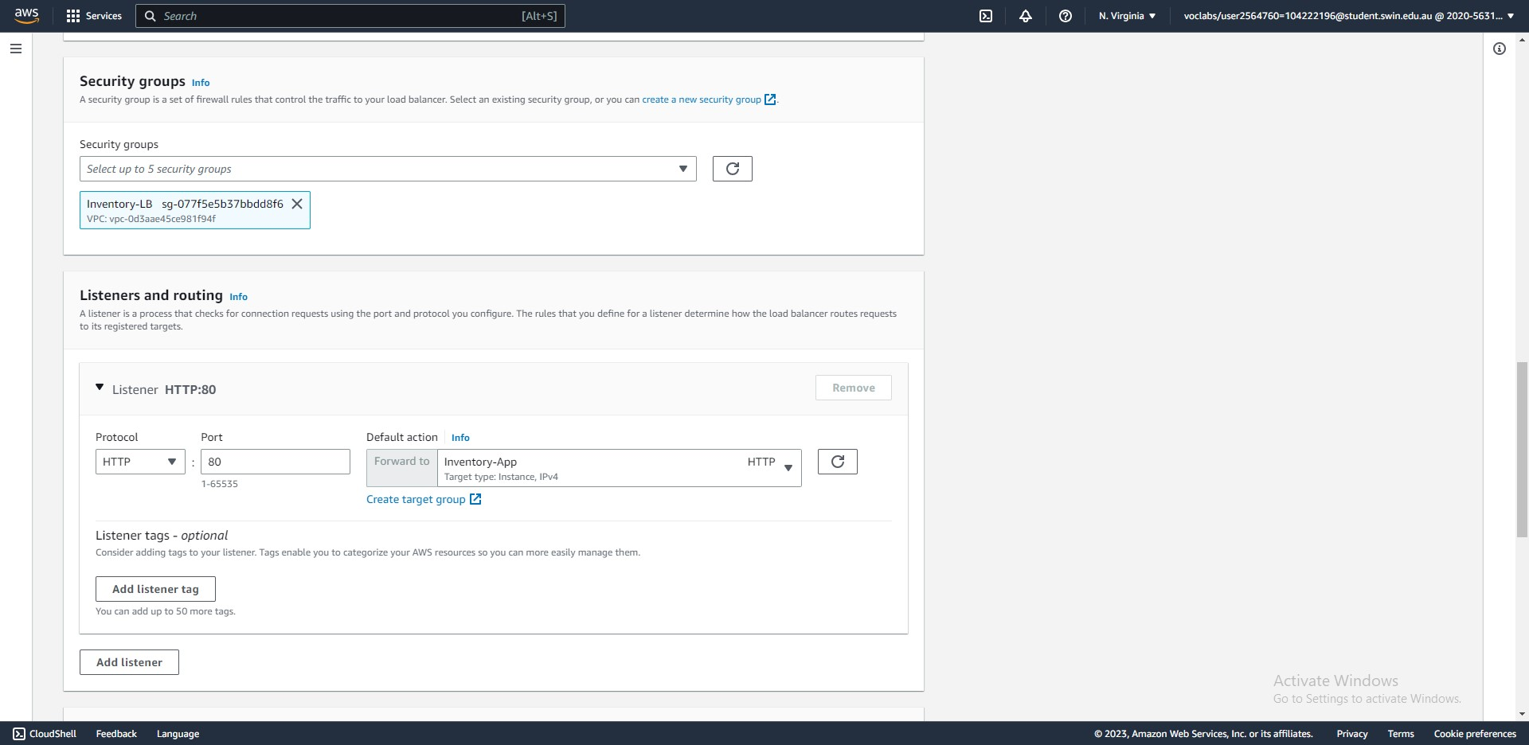



Step 29, 34: Create an application load balancer (assign the Inventory-LB security group and forward HTTP traffic to the Inventory-App group.)

**Task 3 - Creating an Auto Scaling group**

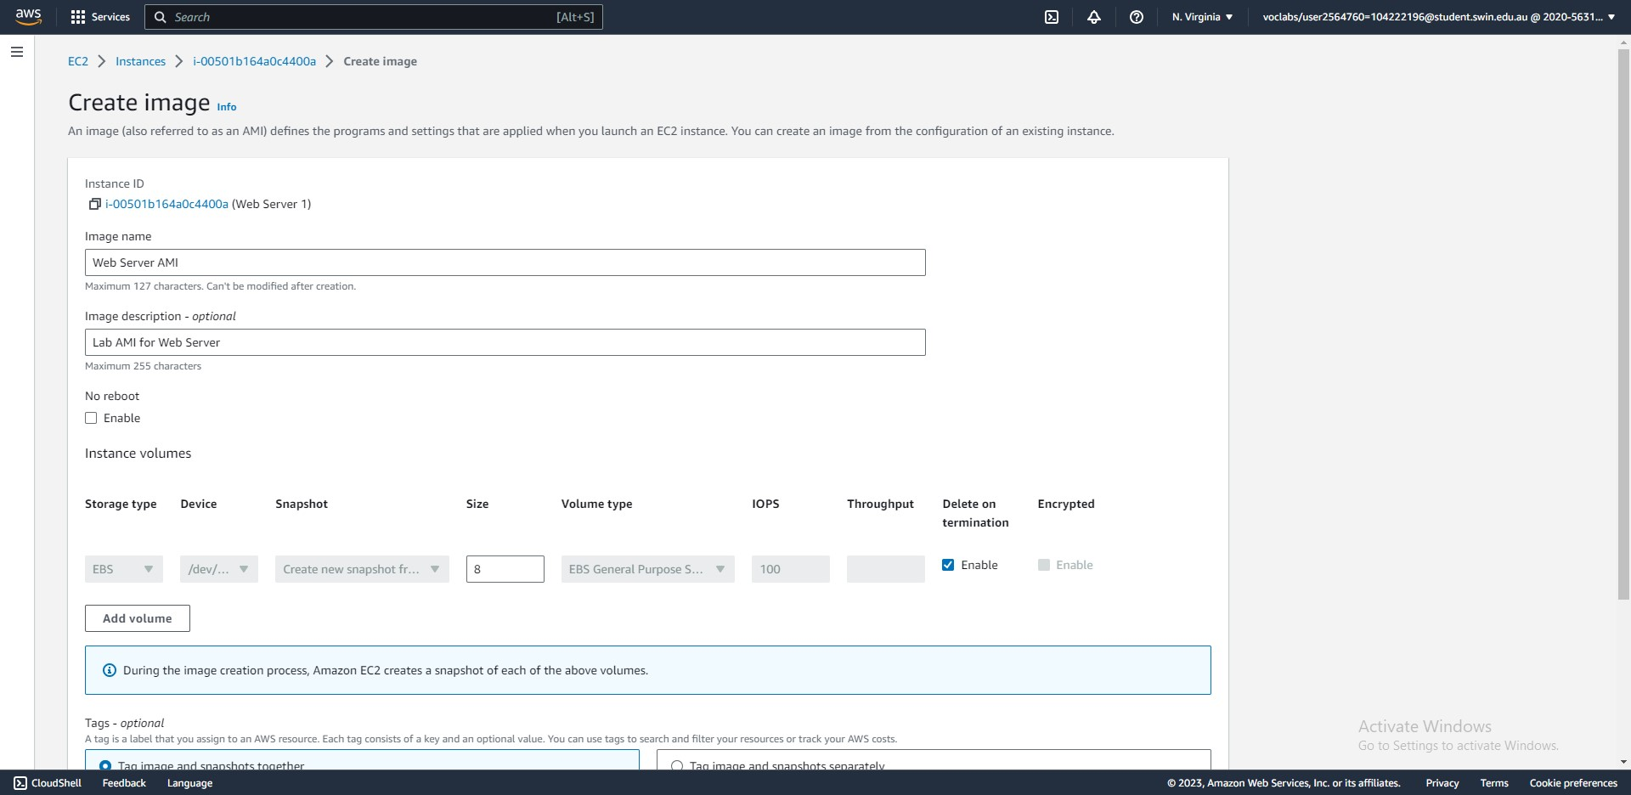



Steps 36-41: Create an AMI from the Web Server.

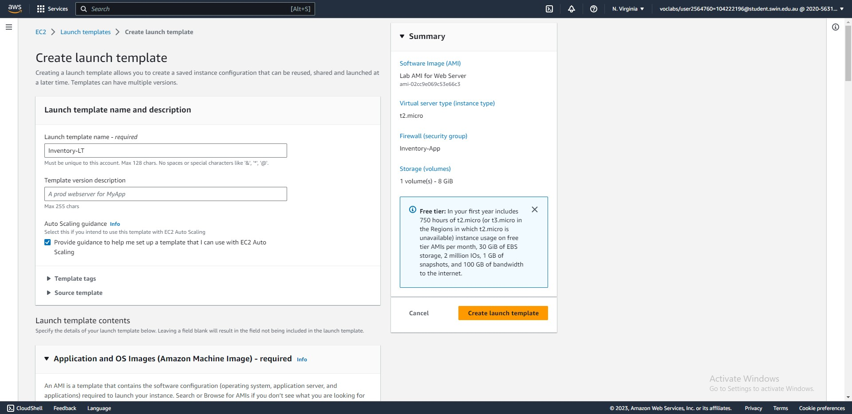



Steps 42-44: Create a launch template (set the name to Inventory-LT and select provide guidance for Auto-scaling)

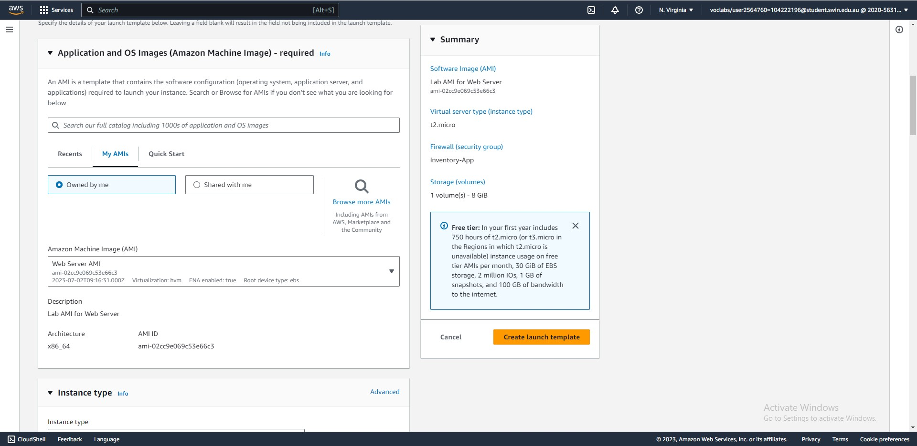



Step 44: Create a launch template (select the Web Server AMI)

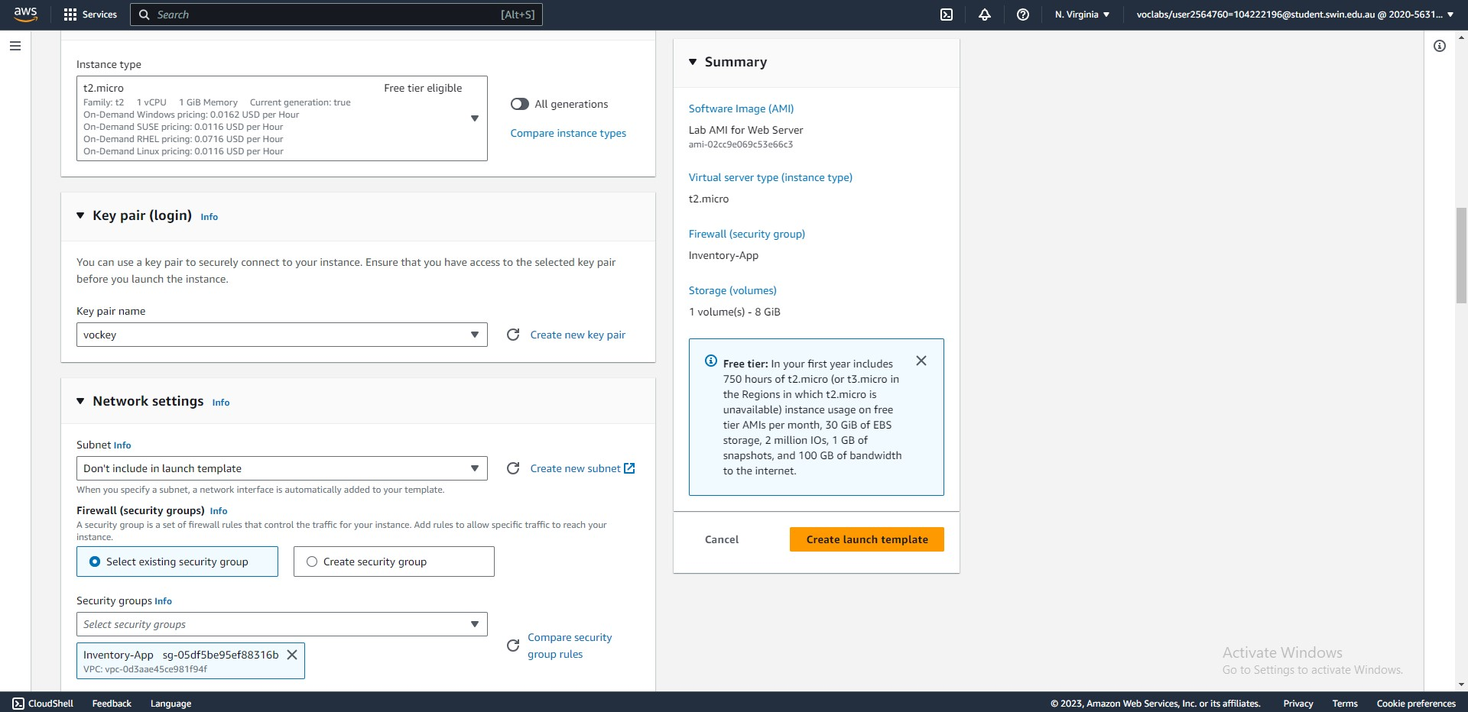



Step 44: Create a launch template (choose the t2.micro instance type, vockey key pair, and Inventory-App security group)

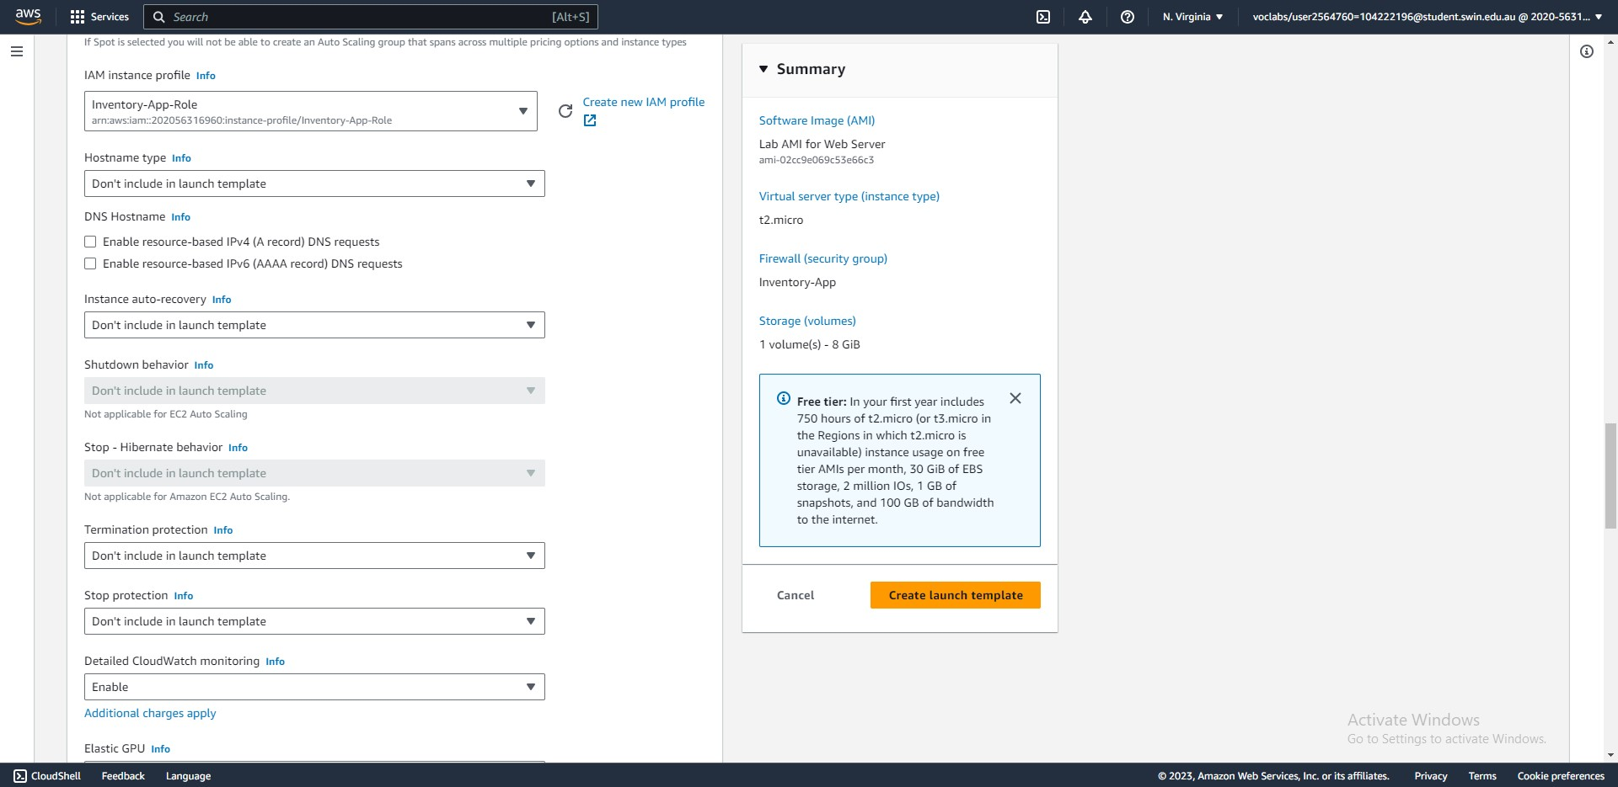



Step 44: Create a launch template (assign the Inventory-App-Role AMI role and enable detailed CloudWatch monitoring).

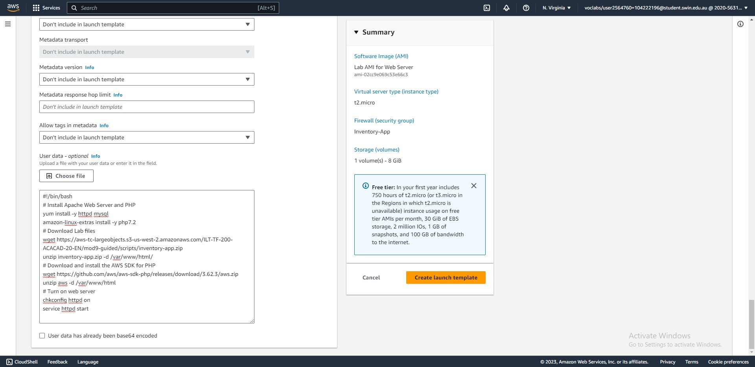



Steps 44-45: Create a launch template (add user data and confirm creation).

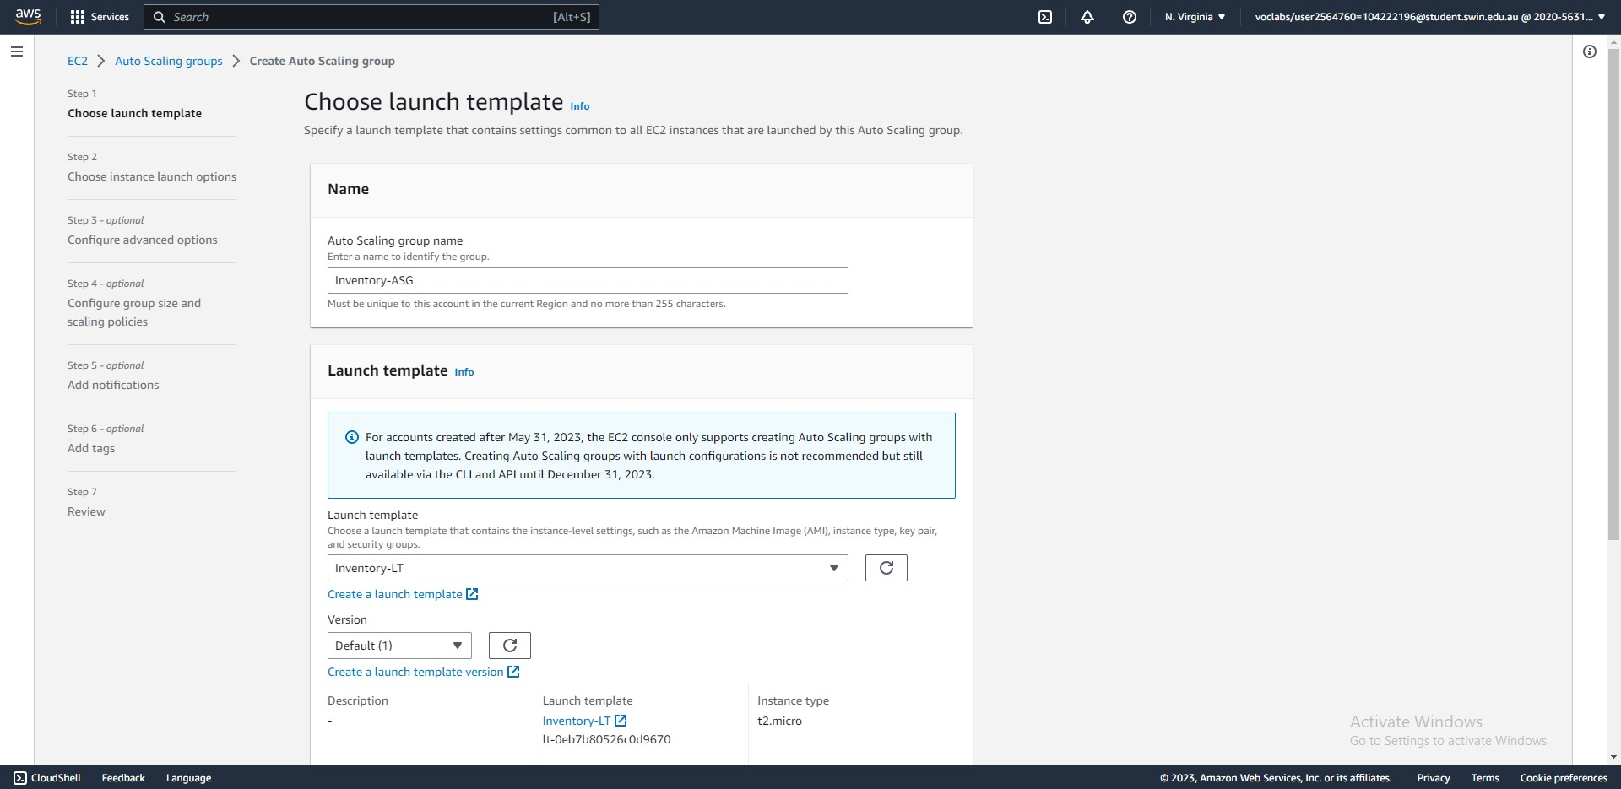



Steps 46-47: Create an auto-scaling group from the launch template (step 1 – set a name and confirm the correct launch template is selcted)

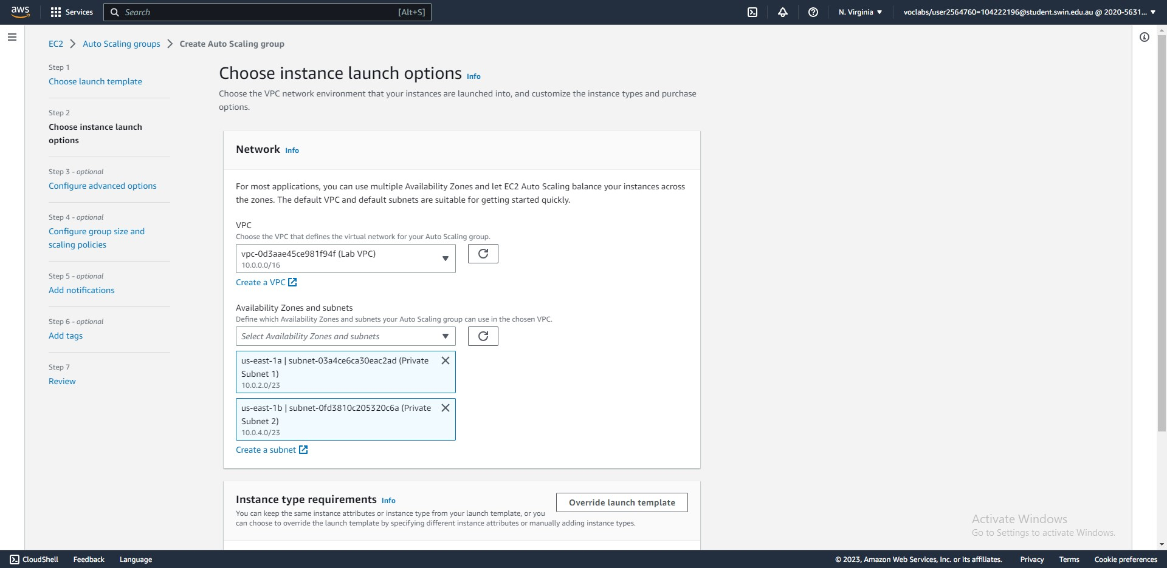



Step 48: Create an auto-scaling group (step 2 – choose to launch instances into the private subnets of the Lab VPC).

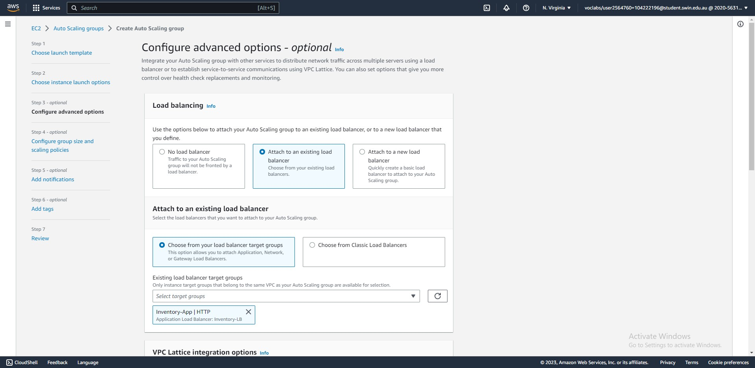



Step 49: Create an auto-scaling group from the launch template (step 3 – attach the group to an exisiting load balancer)

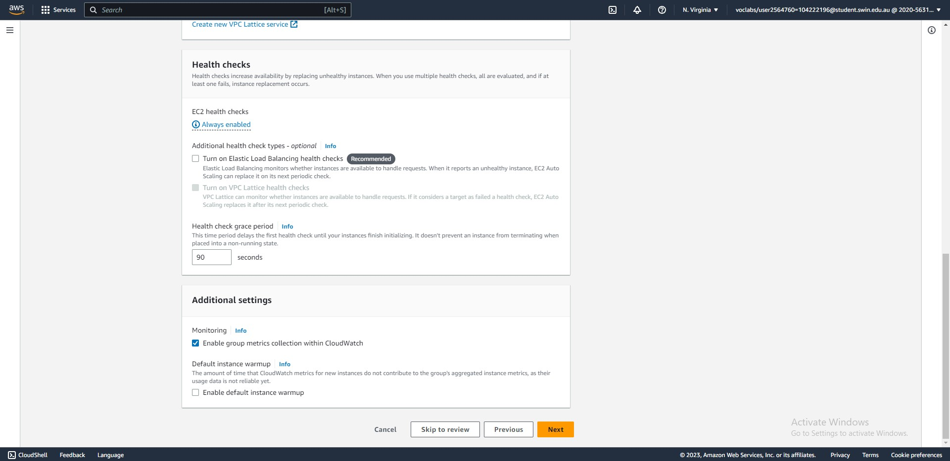



Step 49: Create an auto-scaling group from the launch template (step 3 – modify the health check grace period and enable group metrics collection).

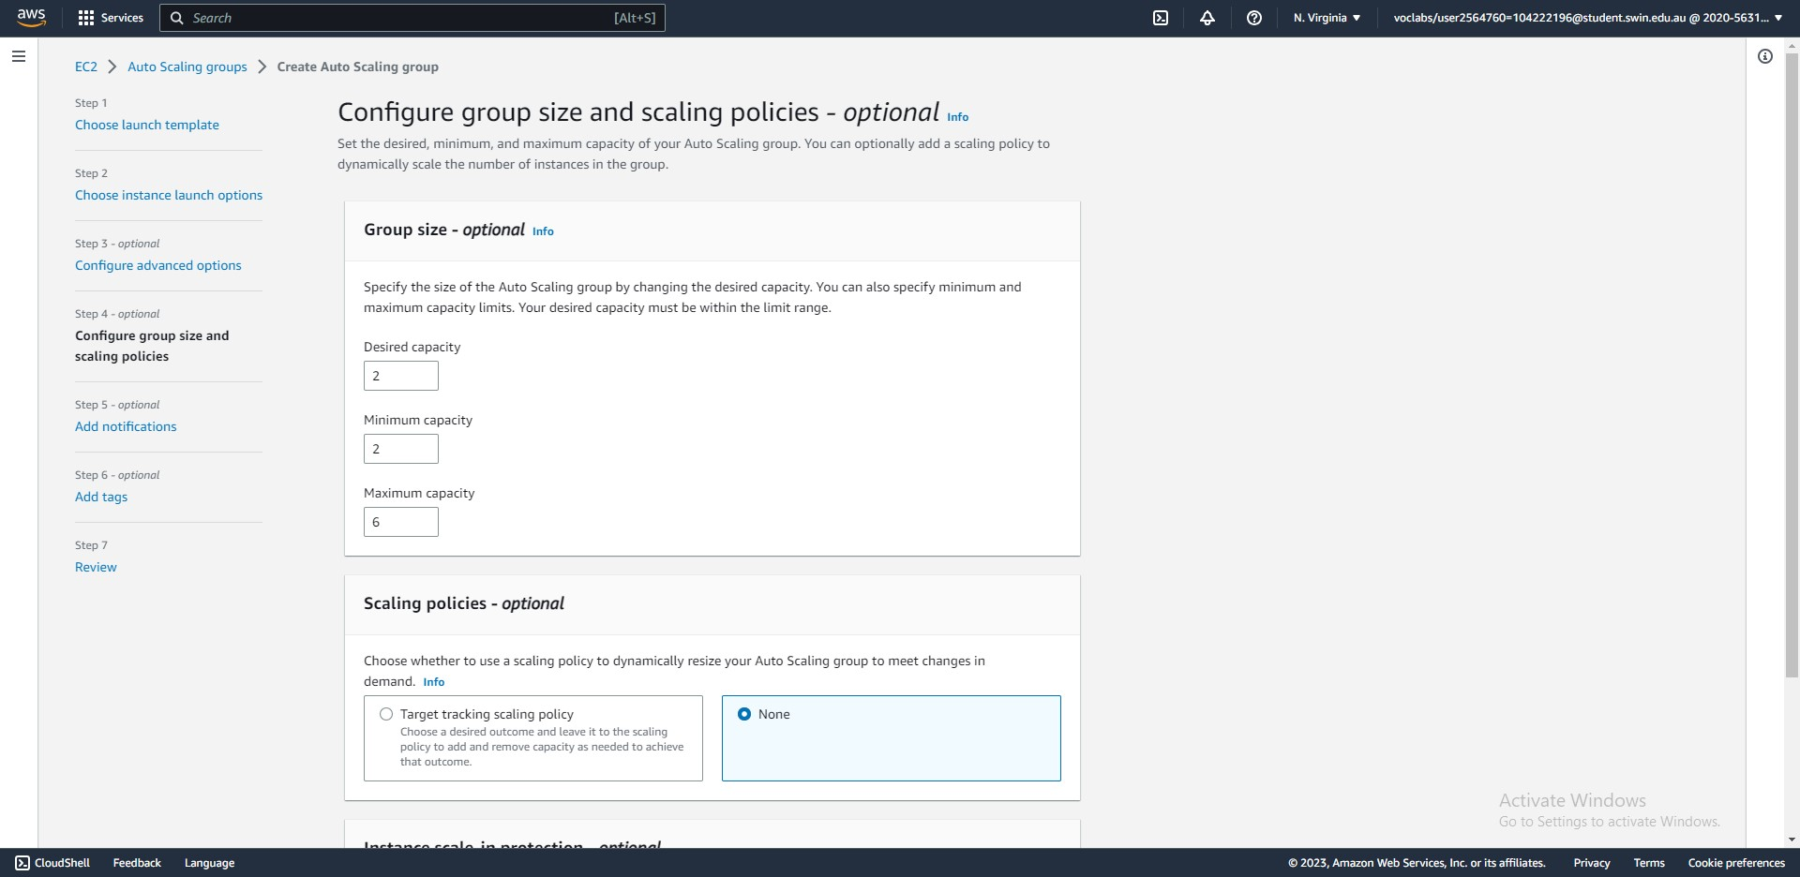



Step 50: Create an auto-scaling group from the launch template (step 4 – set the group size and group scaling policy)

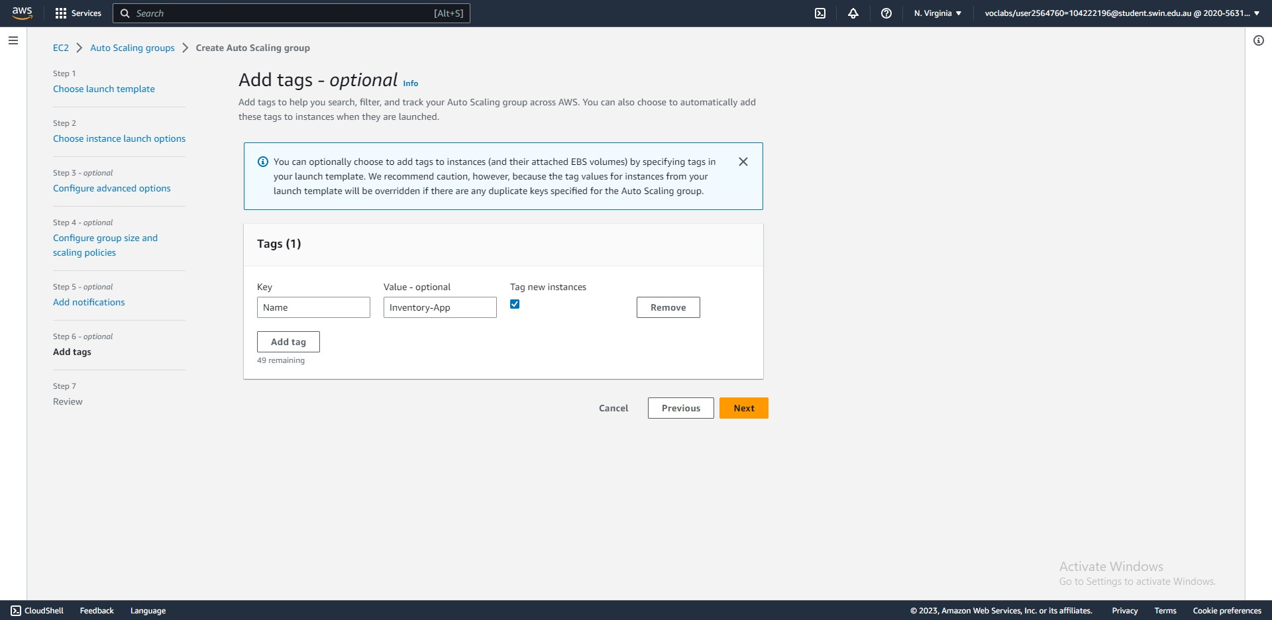



Step 51-52: Create an auto-scaling group from the launch template (skip step 5 – add notifications, add a name tag in step 6)

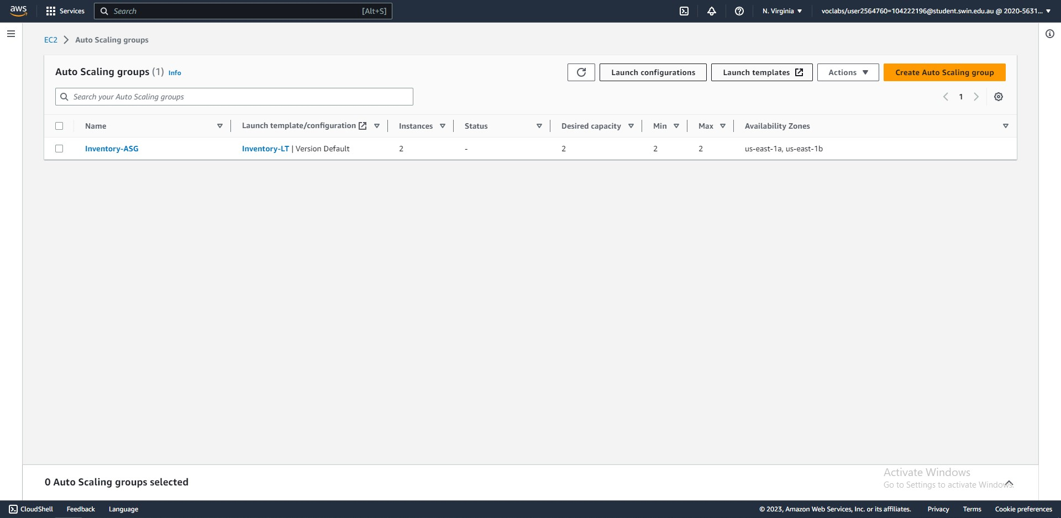



Step 53: After a few minutes, two instances will be launched by the auto-scaling group.

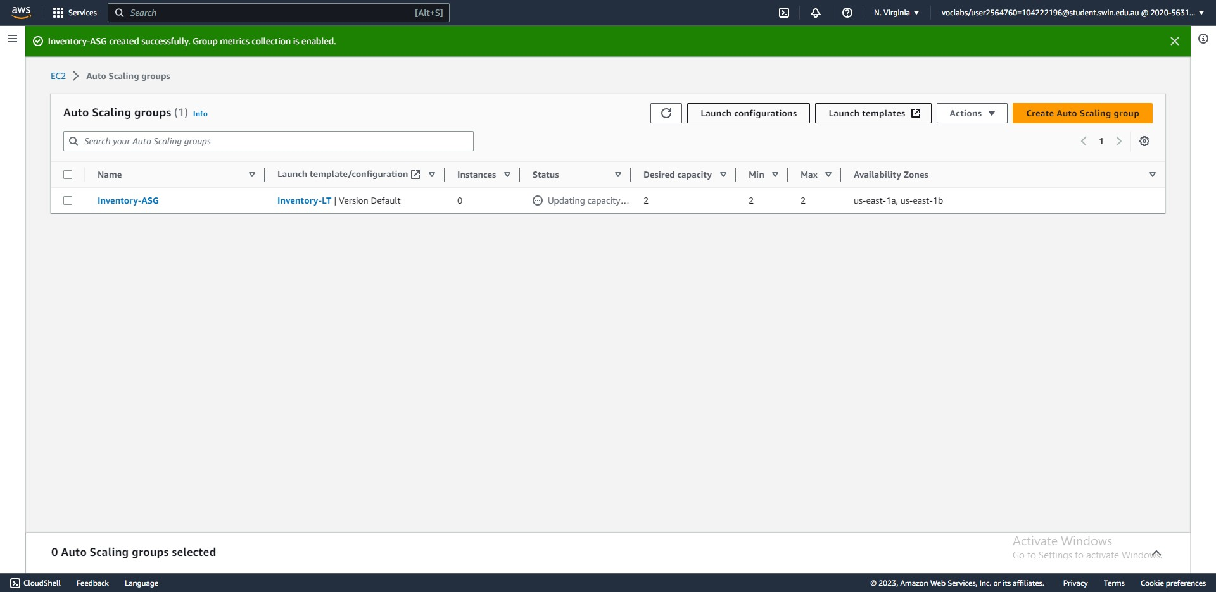



Step 53: After creating the auto-scaling group, it will start with 0 instances.

**Task 4 - Updating security groups**

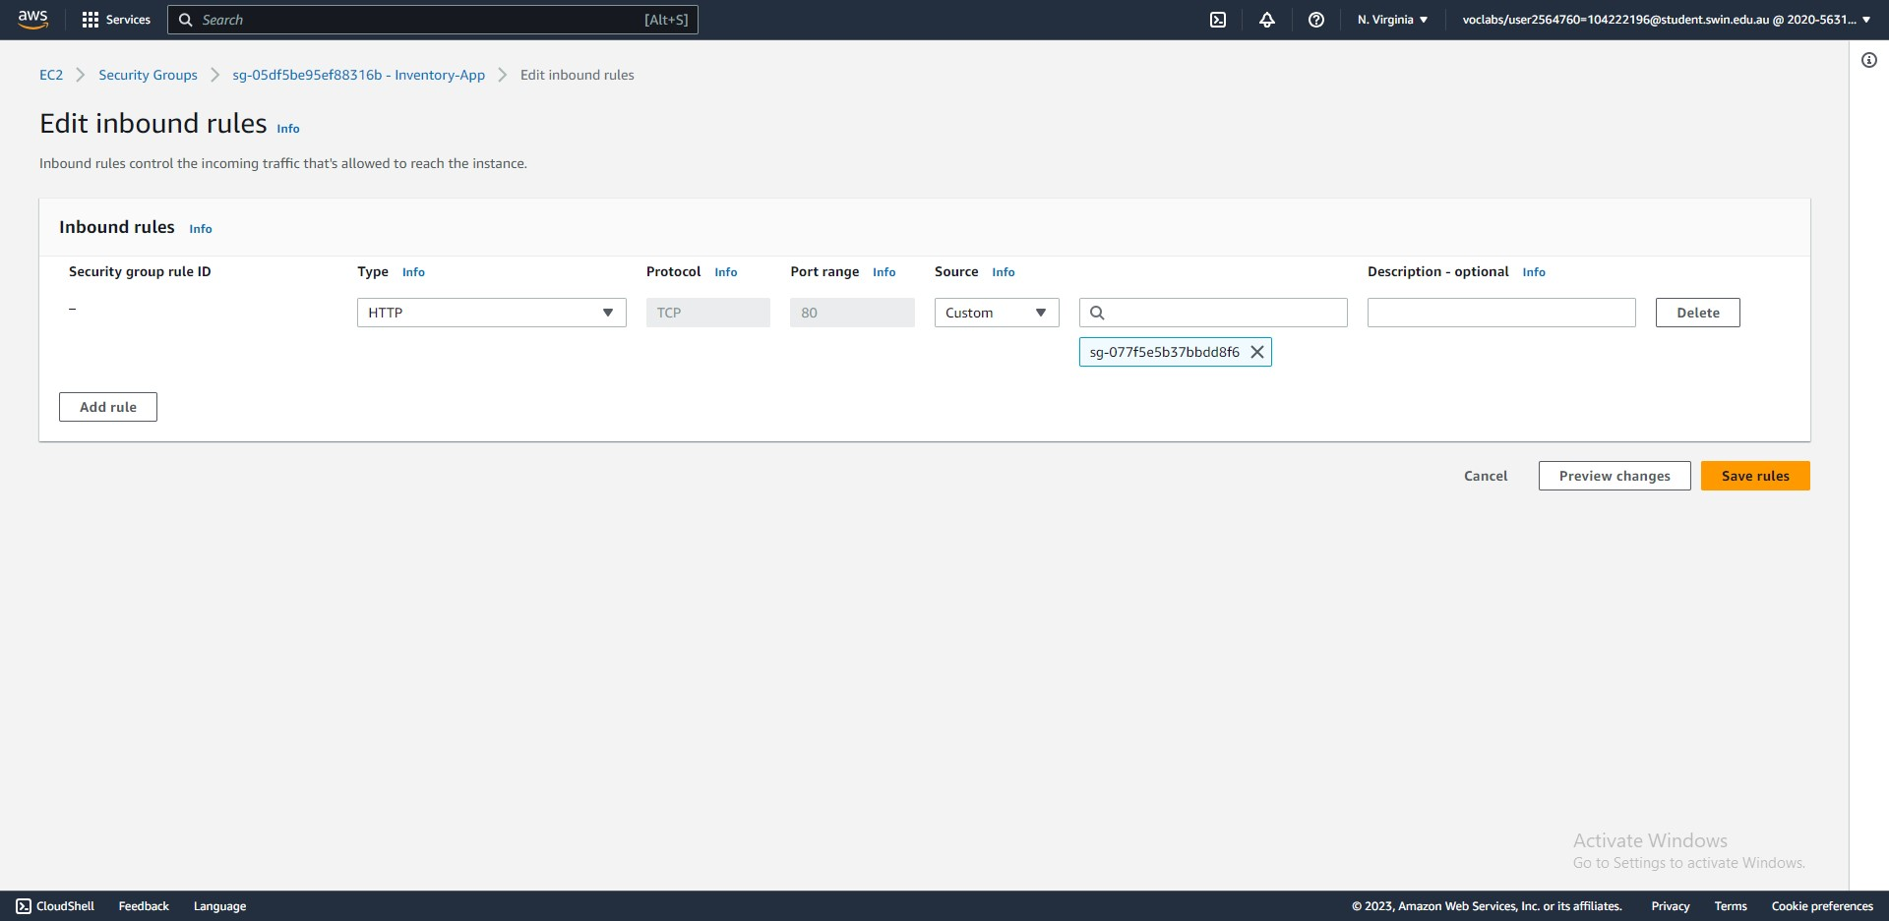



Steps 54-58: Add a rule to the Application security group that allows all HTTP traffic from the load balancer.

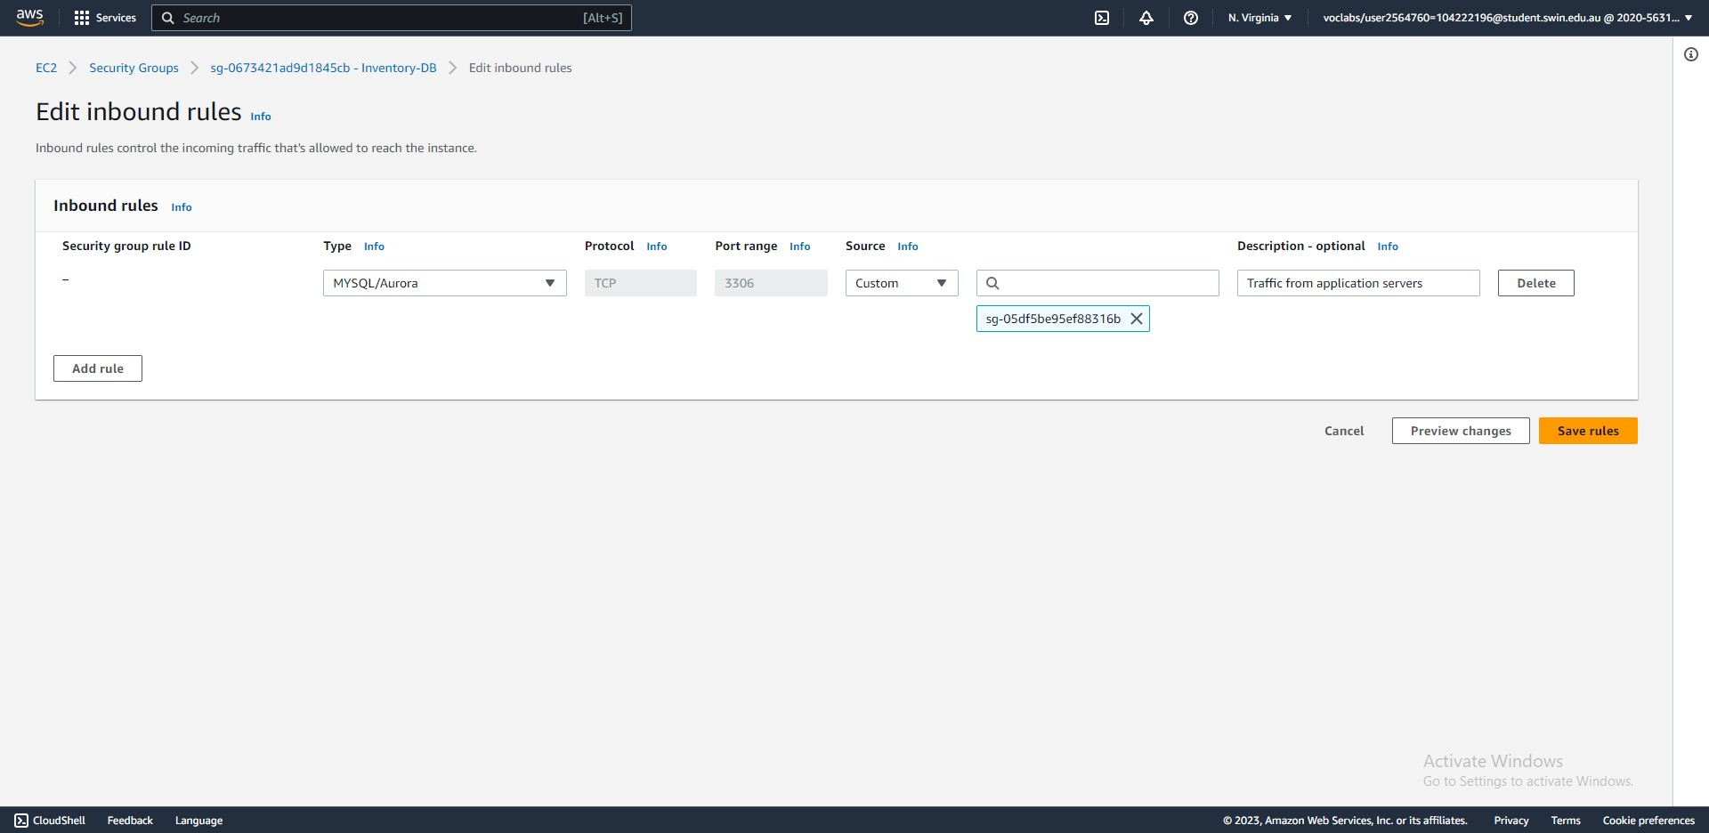



Steps 59-60: Add a rule to the Database security group that allows all inbound MySQL traffic from the Application servers.

**Task 5 - Testing the application**

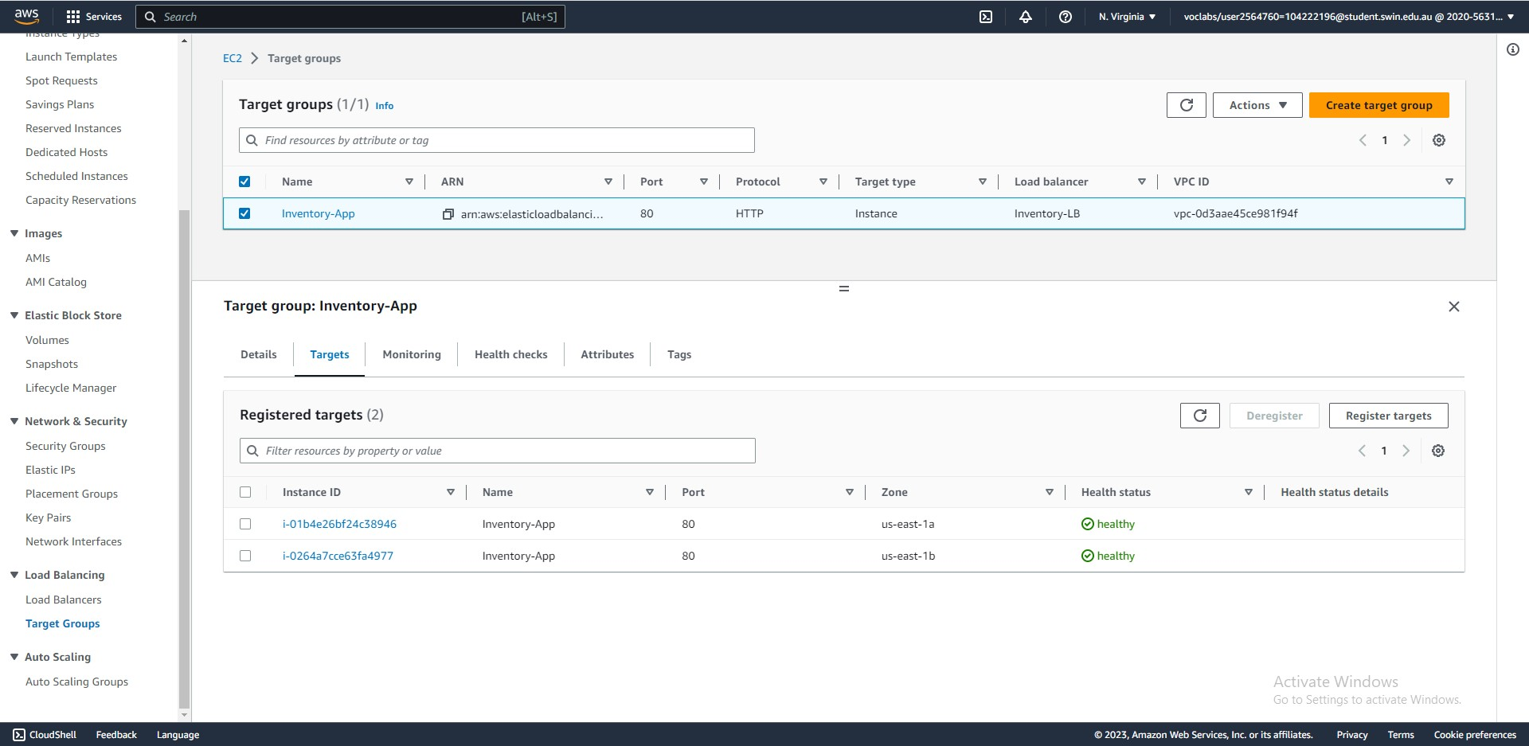



Steps 61-64: Two healthy instances are in the target group.

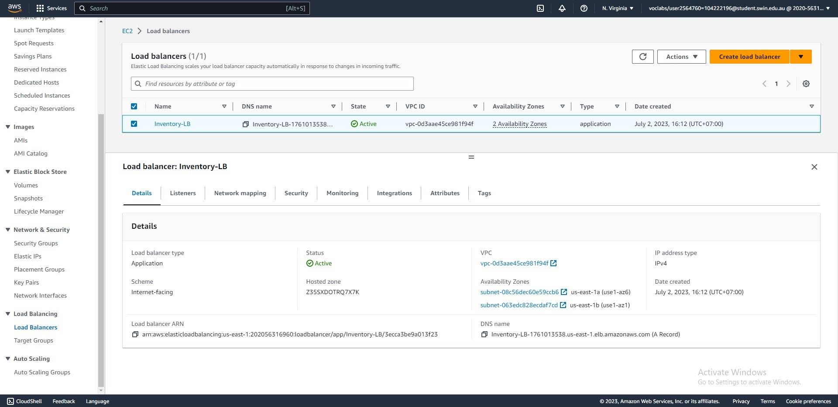



Steps 65-66: Copy the DNS name of the Inventory load balancer.

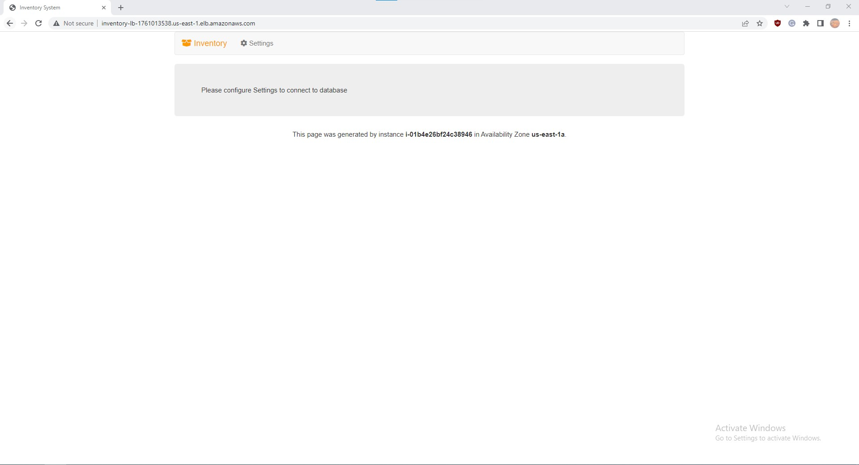



Steps 67-68: Pasting the DNS name into a new browser window results in a webpage hosted on one of the instances in the target group.

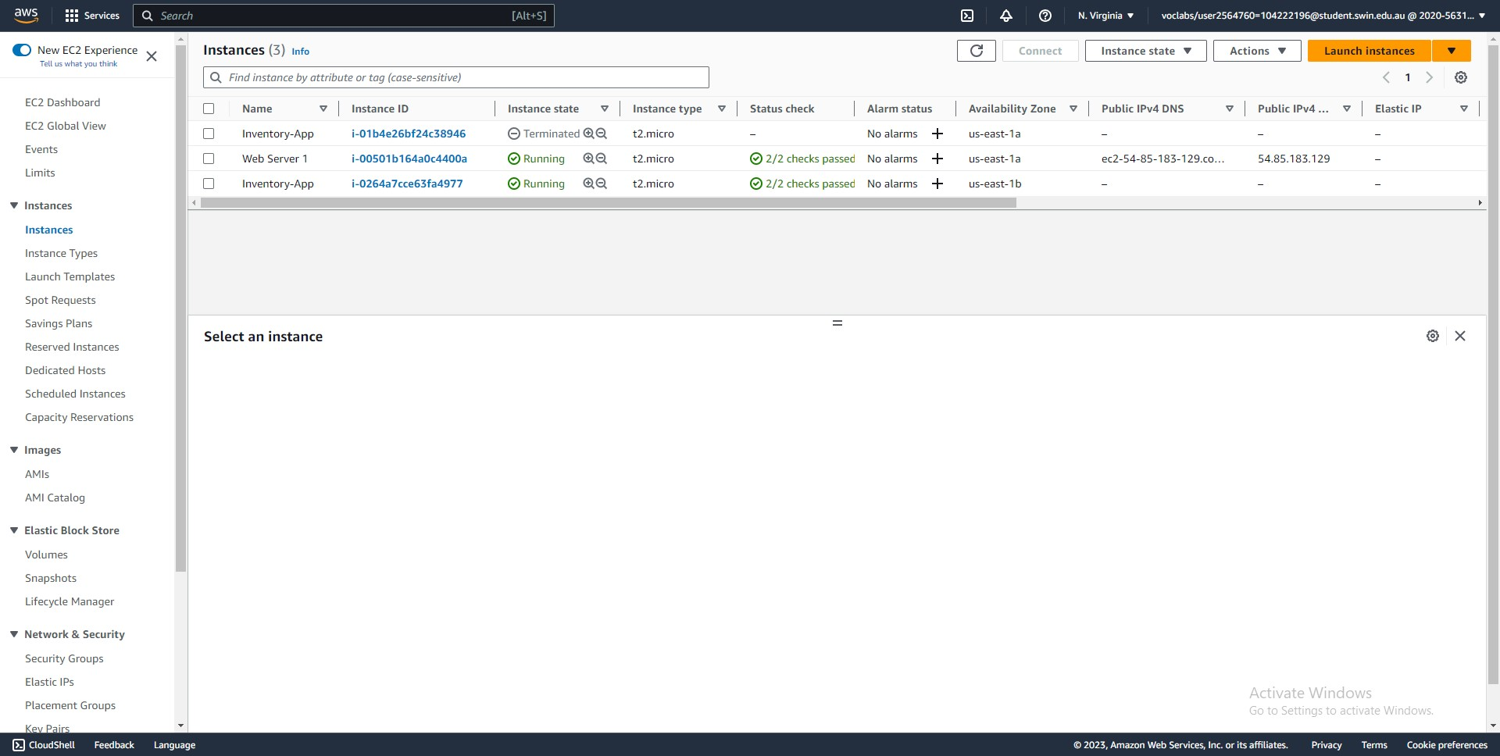



Steps 69-73: Terminate one of the Inventory-App instances.

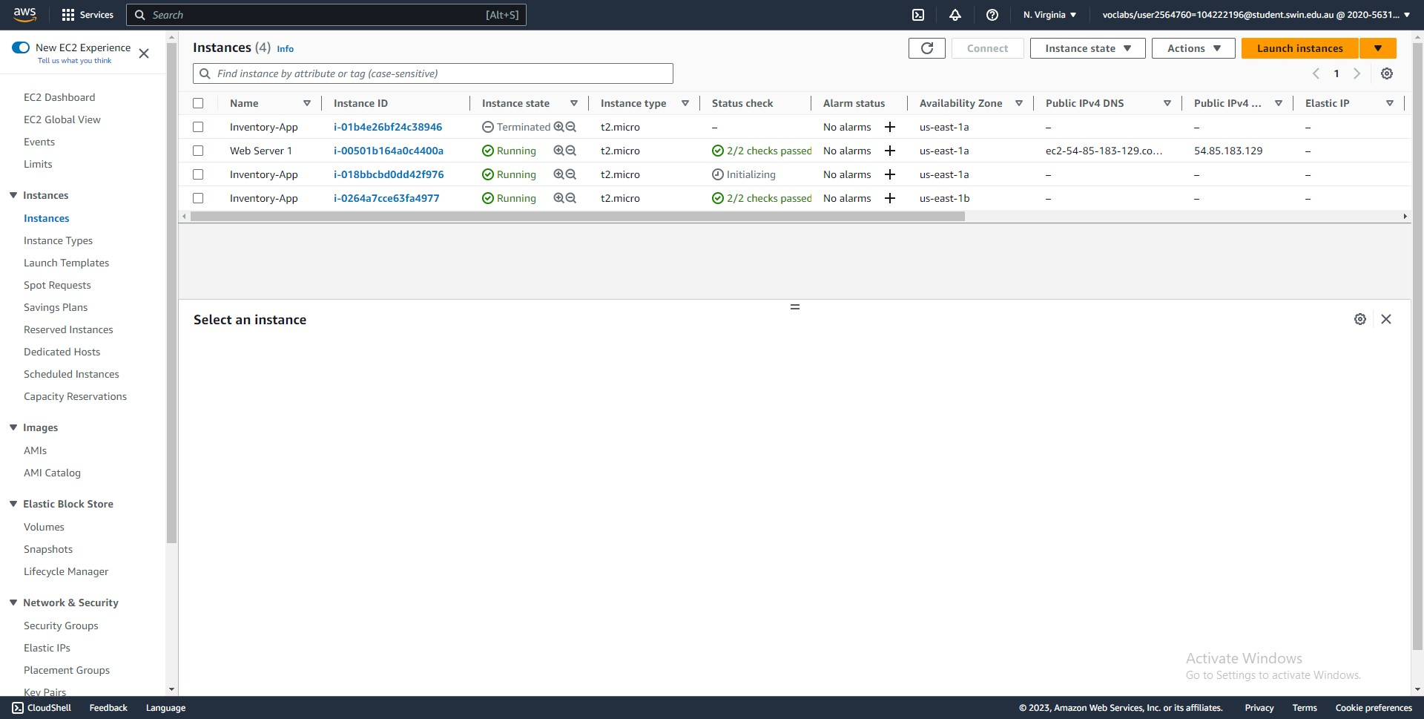



Steps 74-75: The auto-scaling group detects that only one instance is healthy, so it launches another.

**Optional task 1 - Making the database highly available**

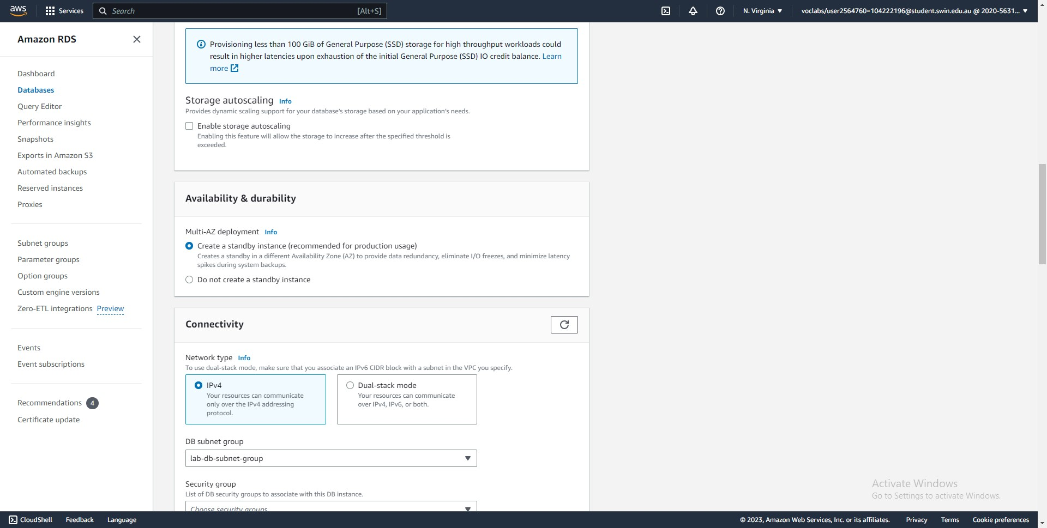



Steps 76-80: Modify the existing RDS instance to create a standby instance.

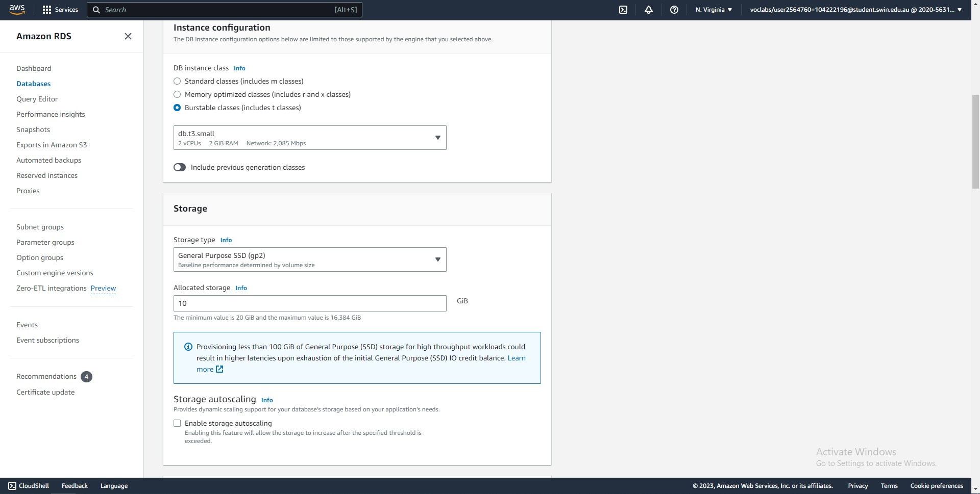



Steps 81-82: Change the instance class to db.t3.small and allocate 10 GiB of storage.

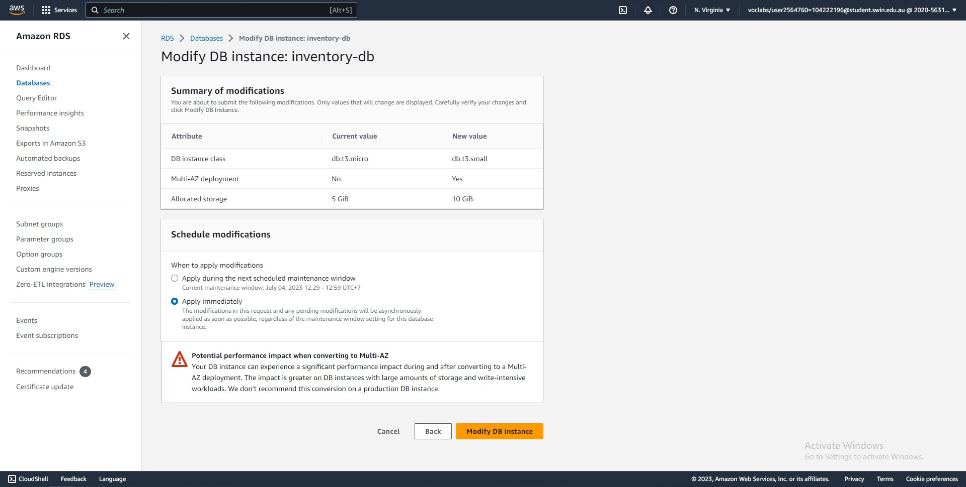



Steps 83-85: Confirm the changes and select apply immediately.

**Optional task 2 - Configuring a highly available NAT gateway**

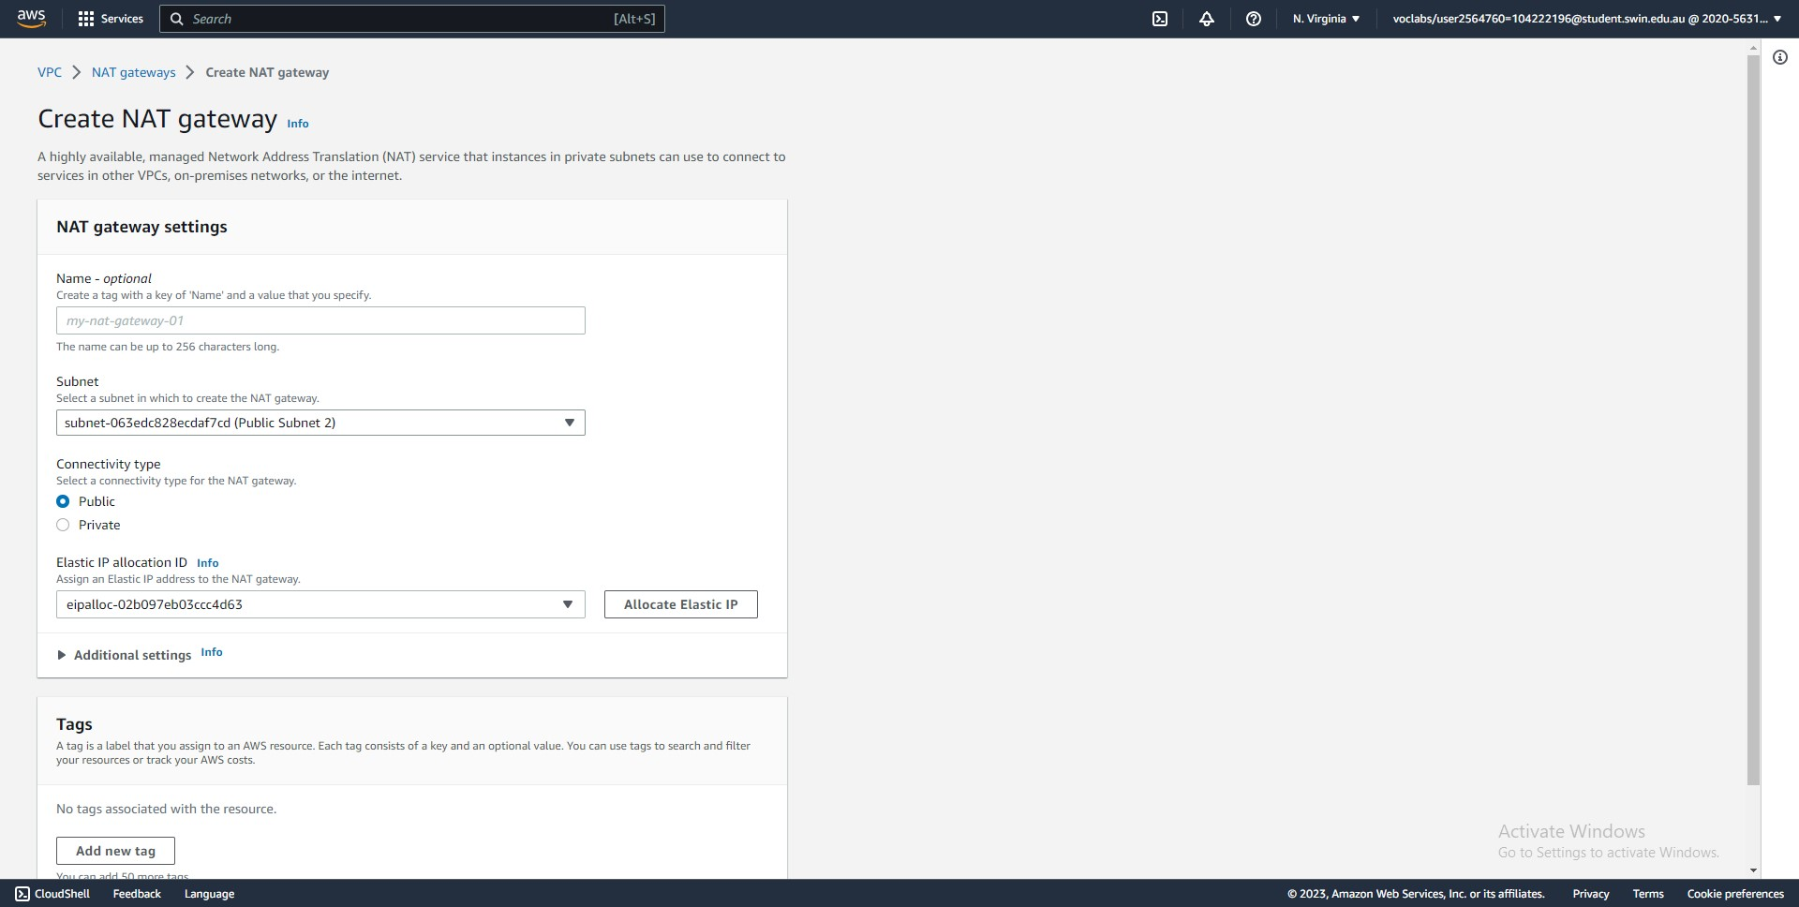



Steps 86-88: Create a new NAT gateway in Public Subnet 2.

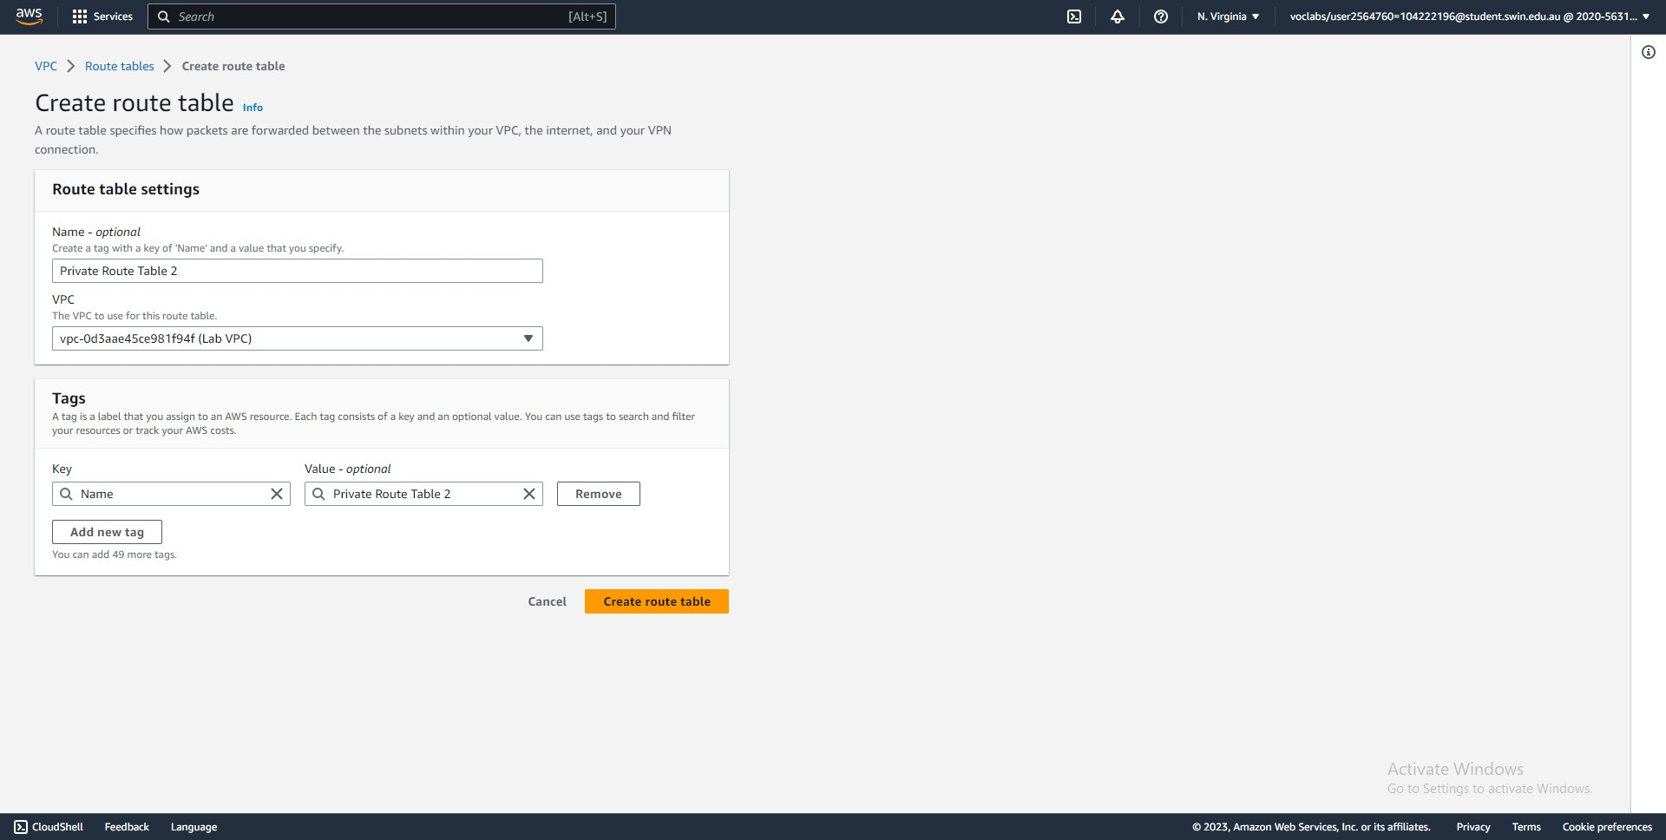



Steps 89-90: Create a new route table in the Lab VPC.

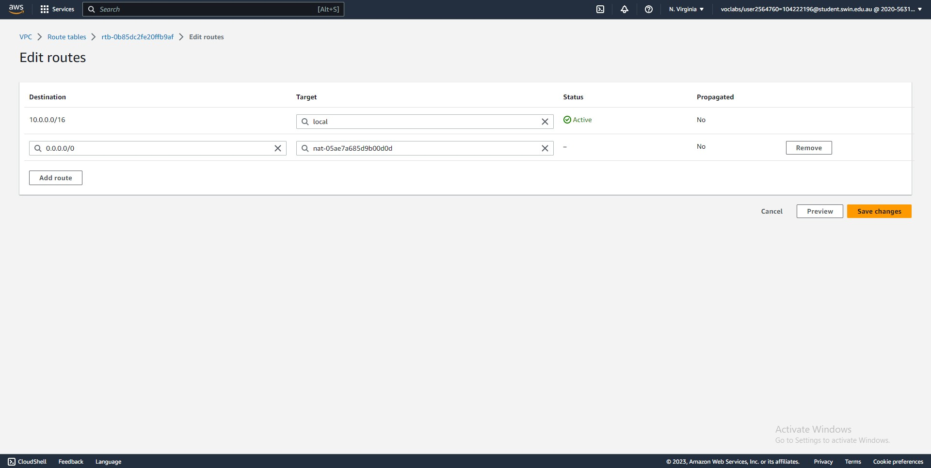



Steps 91-92: Add a route entry that directs all Internet-bound traffic to the newly created NAT gateway.

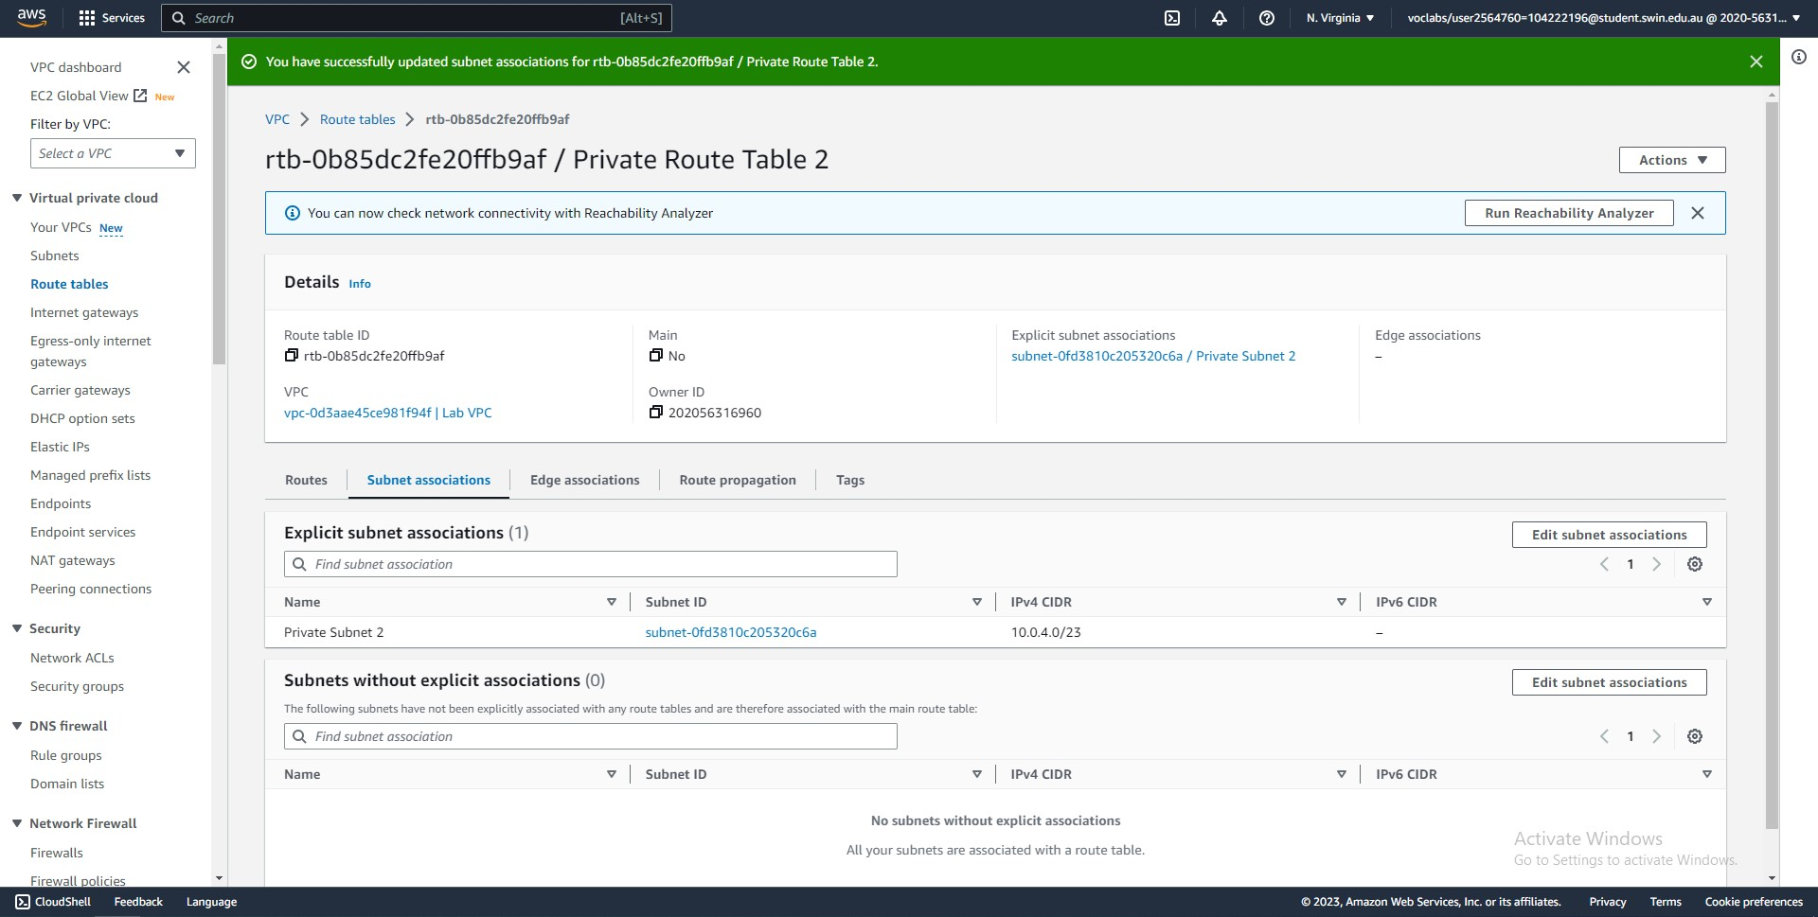



Steps 93-96: Associate Private Subnet 2 with the new route table.